USER INTERFACE DESIGN
CODE :- 23CSE113
LAB MANUAL
SUBMITTED BY
NAME |  | P.Varshith
ROLL NO |  | AV.SC.U4CSE25232
YEAR/SEM/SECTION |  | 1ST YEAR/SEM-2/CSE-C
CREDITS | 03
SUBMITTED TO | DR. RAJ KUMAR BATCHU
DESIGNATION | ASST.PROFFESSOR (Sl. Grade)

S.NO | TITLE | PAGE NO | REMARKS
1 | WEEK 1: 1. Installation of VS Code  2. Understanding basics  of HTML structure  3. Understanding basic  HTML tags. | 5-12
2 | WEEK 2: 1. Create an HTML webpage that could display a amrita webpage with different branches and their locations in a table with background image. | 13-16
3 | WEEK 3: 1. Create an HTML webpage that could display syllabus of all subjects as an image format also the timetable | 17-29
4 | WEEK 4:1.Design a college admission registration form using HTML tags.  2.Create an HTML webpage displaying two forms using iframes. | 18-35
5 | WEEK 5:a. To display three different cards showing information in a HTML page.  b. Create three basic web pages like index.html,home.html,about.html,contact.html.Upon clicking on home,about,contact the content should display in the same page.  c. To design Amrita login page by displaying different campuses on the homepage.Upon clicking on each Campus the details about the campus should be displayed on the same page.Use HTML and CSS to design stylish webpage. | 36-49
6 | WEEK-6:Design a responsive e-commerce application using the grid layout. This application should contain different categories of products such as electronics, clothing, home-appliances, books. Based on the category we select corresponding products should be displayed on the sidebar. | 50-59
7 | WEEK-7:Create a GitHub account and create a repository in it and push all the week 6 code files in it. | 60-62
8 | WEEK-8:1.Create a webpage that displays a square that continuously rotates 360 using CSS animations.  2.Create a ball that moves up and down continuously using CSS animation.  3.Create a circle that moves horizontally and rotates at the same time. | 63-70
9 | WEEK-9:Create an webpage using html, CSS, java script based on the given conditions:  a)Create a button for each program, based on the button clicked the corresponding program has to be executed and should display the output.  b)The logics for each button includes finding an even numbers, odd number, prime or not, factorial of a number, amstrong or not.  c)Use appropriate designs to display the output. | 71-79
10 | - Write a JavaScript conditional statement to find the sign of product of three numbers using functions.Display an alert box with the specified sign.  - Write a JavaScript conditional statements to sort three numbers using functions.Display an alert box to show the result.  - Write a JavaScript conditional statements to find the largest of five numbers using function and on click event.Display an alert box to show the result.  - Write a JavaScript for loop that will iterate from 0 to 15.For each iteration, it will check if the current number is odd or even, and display a message to the screen. | 80-100
11 | WEEK-11:1. A website requires users to enter a username. The system should display a message while typing if the username is less than 5 characters.  2. A registration form should validate email format before submission. If invalid, the form should not be submitted.  3. A system should check password strength while typing and display whether it is weak or strong.  4. A form should validate a mobile number when the user leaves the input field. The number must be exactly 10 digits.  5. Design an HTML page, such that the registration form must validate:  Name (not empty)  Email (valid format)  Password (minimum 6 characters) | 101-125
12 | WEEK-12: Installation of Electron website | 126-131
WEEK-1
- AIM:- To install VS Code
PROCEDURE:-
STEP-1: 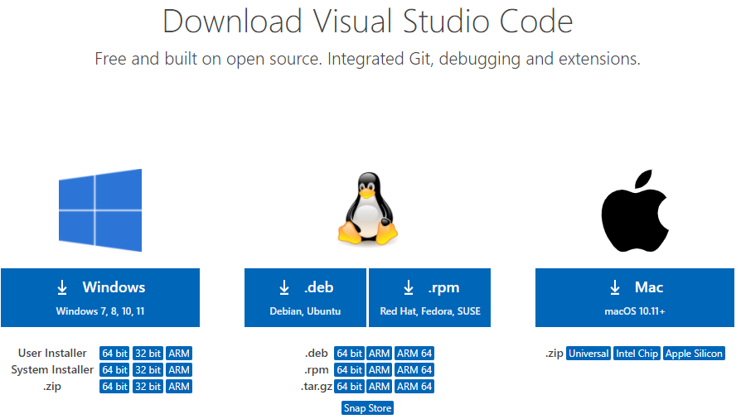
STEP-2:

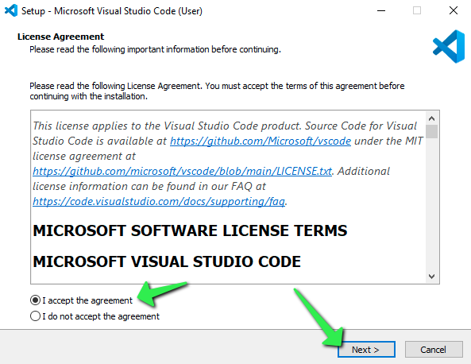 STEP-3:

STEP-4:

STEP-5:
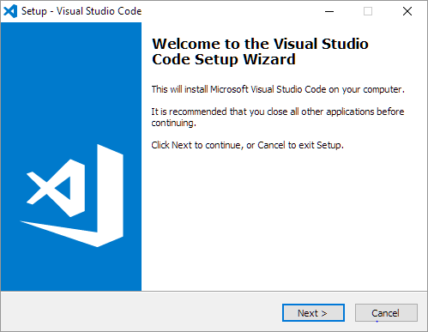
STEP-6:
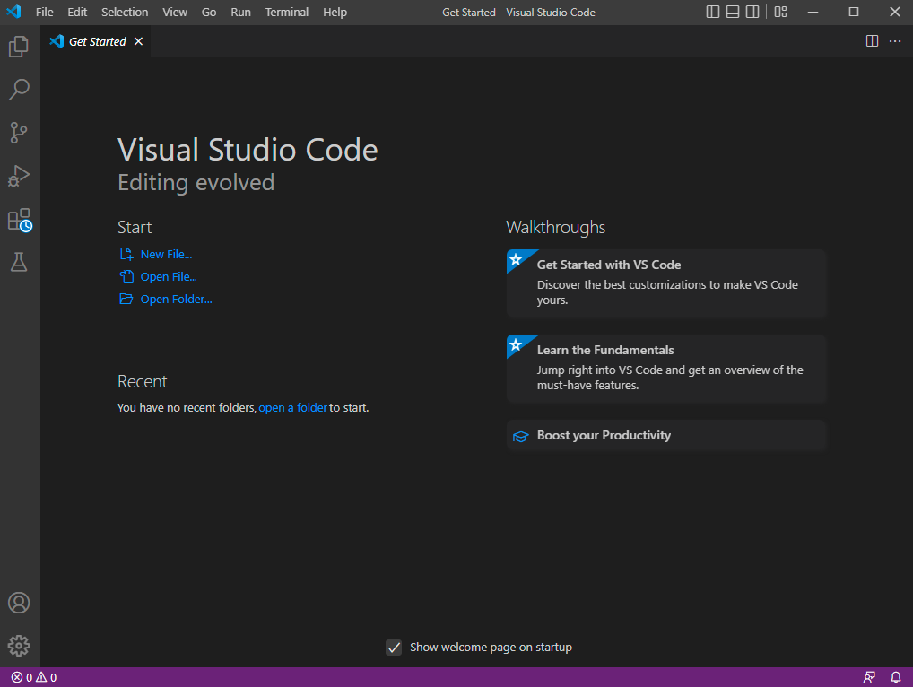
- AIM:- To understand the basics of HTML.
Code:-
UID-25232
<!DOCTYPE html>
<html>
<head>
<title>First Web Page</title>title>
</head>
<body>
<h1>Happy to learn HTML</h1>
<p>This is my first sample code</p>
</body>
</html>

OUTPUT:-
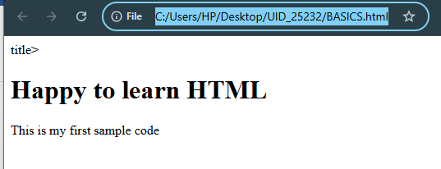
Explanation of tags:-
- HTML stands for Hyper Text Markup Language.
- HTML is the standard markup language for creating Web pages.
- HTML describes the structure of a Web page.
- <!DOCTYPE html>: It declares that the document is written in HTML5.
- <html> ... </html>: It is root element of the HTML document. All HTML code is written inside this tag.
- <head> ... </head>: Contains metadata about the webpage. Information inside <head> is not displayed on the webpage.
- <title>Page Title</title>: Specifies the title of the webpage. The title appears on the browser tab.
- <body> ... </body>: Contains the visible content of the webpage.
- <h1>: <h1> is the largest heading tag.
- <p>: <p> defines a paragraph.

3 . Aim:-Understanding the basic HTML tags
Tags-<p>;<h1>;<img>;<color>.
Code:-
UID-25232
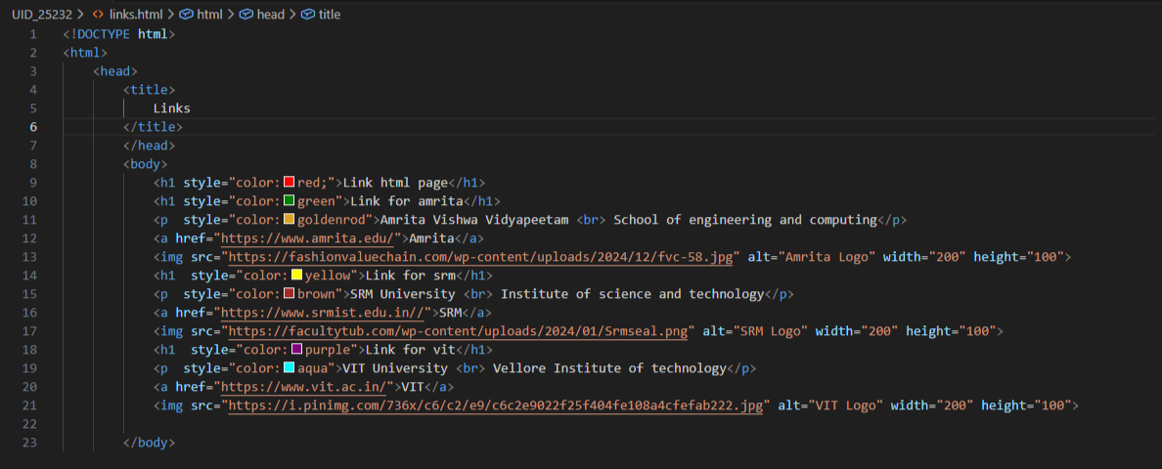
Output:-
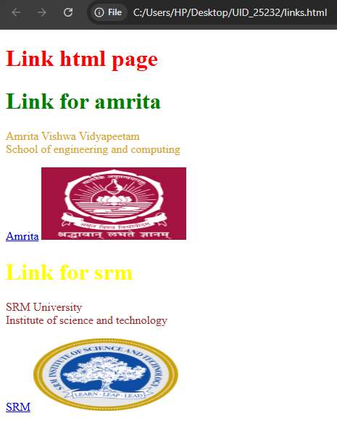


If we click the amrita link then we get this page

If we click srm link then we get this page

If we click on vit link then we get this page

Explanation of tags:-
<br>: The HTML <br> element defines a line break. it is an empty tag with no end tag.
Style: The HTML style attribute is used to add styles to an element such as color, font, size and more.

<img> : The <img> tag is a fundamental HTML element used to embed an image into a web page.

<a> : The HTML <a> tag ,which stands for “anchor”, is used to define a hyperlink.

WEEK-2
Aim:- Create an HTML webpage that could display a amrita webpage with different branches and their locations in a table with background image.
Code:-
<!DOCTYPE html>
<html>
<head>
<title>Amrita Vishwavidyapeetham</title>
</head>
<body style="background-image: url('background.jpg');
background-size: cover;
background-repeat: no-repeat;">

<h1 align="center"
style="border:3px solid purple; color:maroon; padding:10px;">
Amrita Vishwavidyapeetham
</h1>
<p align="center" style="color:goldenrod; font-style:italic; width:80%; margin:auto;">
Mata Amritanandamayi Devi (born Sudhamani Idamannel on September 27, 1953),
known fondly as Amma ("Mother") or the "hugging saint", is a world-renowned
Indian spiritual leader and humanitarian from Kerala. She is globally recognized
for embracing millions as a profound act of compassion, offering unconditional
love to alleviate physical and emotional suffering.
</p><br><br>
<center>
<table border="2" cellpadding="8" cellspacing="0" width="70%"
style="background-color:lightgreen;background-image: url('amrita.jpg');
background-size: cover;
background-repeat: no-repeat;">

<tr>
<th colspan="5" style="background-color:aqua; font-size:20px;">
AMRITA VISHWAVIDYAPEETHAM BRANCHES
</th>
</tr>

<tr style="background-color:rgba(255,255,255,0.7);">
<th>S.No</th>
<th>Campus</th>
<th>Location</th>
<th>Contact No</th>
<th>Contact Person</th>
</tr>

<tr>
<td align="center">1</td>
<td>Amaravati Campus</td>
<td style="background-color:rgba(255,255,255,0.6);">Kuragallu</td>
<td>+91 9865784585</td>
<td>Rajkumar</td>
</tr>

<tr>
<td align="center">2</td>
<td>Amritapuri Campus</td>
<td style="background-color:yellow;">Amrita Nagar</td>
<td>+91 9231184586</td>
<td>Aditya Raj</td>
</tr>

<tr>
<td align="center">3</td>
<td>Coimbatore Campus</td>
<td style="background-color:yellow;">Ettimadai</td>
<td>+91 9876543210</td>
<td style="background-color:violet;">Aashish</td>
</tr>

</table>
</center>

</body>
</html>

Output:-
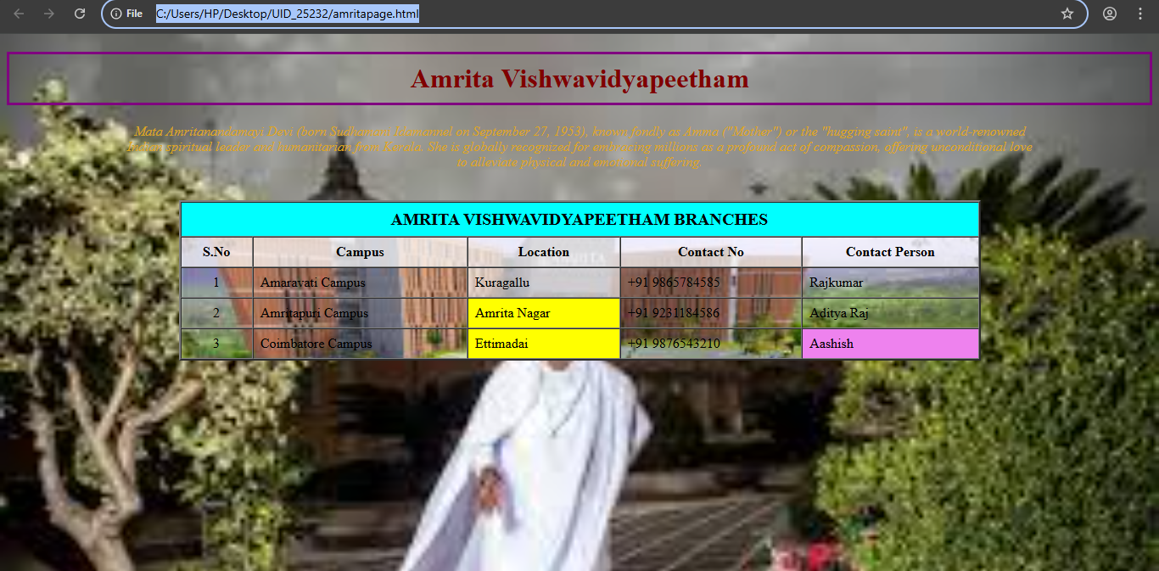
Explanation of Tables in HTML:-

Table Cells
Each table cell is defined by a <td> and a </td> tag.
td stands for table data.
Everything between <td> and </td> is the content of a table cell.

Table Rows
Each table row starts with a <tr> and ends with a </tr> tag.
tr stands for table row.

Table Headers
Sometimes you want your cells to be table header cells. In those cases use the <th> tag instead of the <td> tag.
th stands for table header.

HTML Table - Cell Padding
Cell padding is the space between the cell edges and the cell content.
By default the padding is set to 0.

HTML Table - Cell Spacing
Cell spacing is the space between each cell.
By default the space is set to 2 pixels.
HTML tables can have cells that span over multiple rows and/or columns.

HTML Table - Colspan
To make a cell span over multiple columns, use the colspan attribute.

HTML Table - Rowspan
To make a cell span over multiple rows, use the rowspan attribute.

WEEK-3

1.Aim:-To create an HTML webpage that could display syllabus of all subjects as an image format also the timetable.
Code:
UID-25232
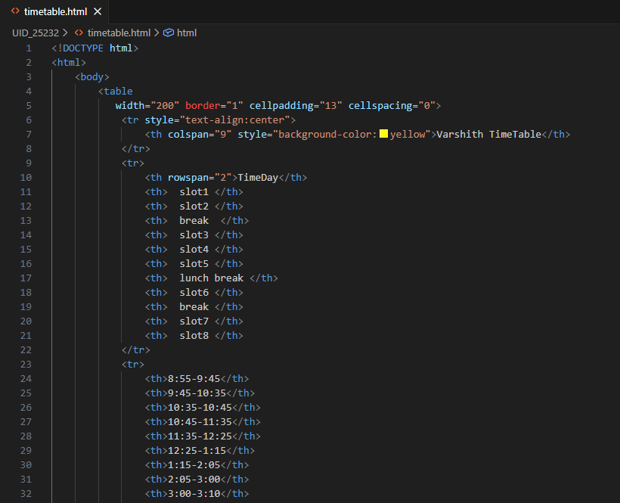

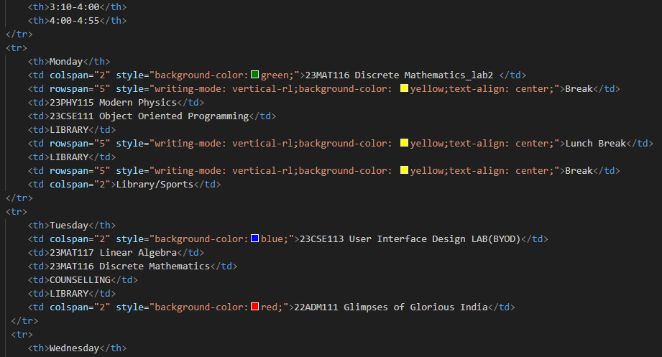
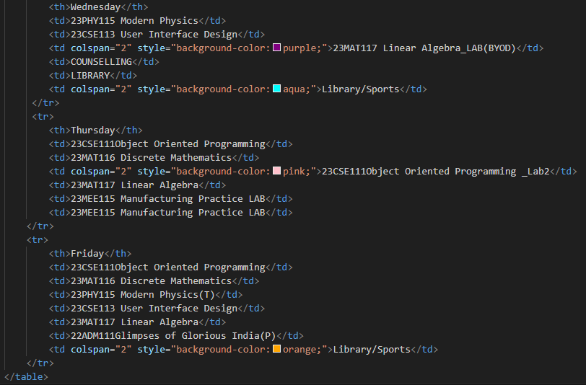
<br><br>
<table width="1200" border="2" cellspacing="0" align="center">
<tr>
<th>Course Code</th>
<th>Course Name</th>
<th>L-T-P</th>
<th>Credits</th>
<th>Faculty Name</th>
<th>Assisting Faculty</th>
</tr>
<tr>
<th>23MAT116</th>
<th>Discrete Mathematics</th>
<th>3-0-2</th>
<th>4</th>
<th>Dr.Srivivasa Rao Thota</th>
<th></th>
</tr>
<tr>
<th>23MAT117</th>
<th>Linear Algebra</th>
<th>3-0-2</th>
<th>4</th>
<th>Mr.Sapavat Bixapathi</th>
<th></th>
</tr>
<tr>
<th>23CSE111</th>
<th>Object Oriented Programming</th>
<th>3-0-2</th>
<th>4</th>
<th>Dr.SATYA RAJENDRA SINGH R </th>
<th>Dr. Balaji TK</th>
</tr>
<tr>
<th>23PHY115</th>
<th>Modern Physics</th>
<th>2-1-0</th>
<th>3</th>
<th>Dr.Soumya</th>
<th></th>
</tr>
<tr>
<th>23CSE113</th>
<th>User Interface Design</th>
<th>2-0-2</th>
<th>3</th>
<th>Dr.Rajkumar Batchu </th>
<th>Mr. Barge Bharadwaj</th>
</tr>
<tr>
<th>23MEE115</th>
<th>Manufacturing Practice</th>
<th>0-0-3</th>
<th>1</th>
<th>Dr. Sathies S.</th>
<th></th>
</tr>
<tr>
<th>22ADM111</th>
<th>Glimpses of Glorious India </th>
<th>2-0-1</th>
<th>2</th>
<th>Dr. Siva Panuganti</th>
<th></th>
</tr>
</table>
<h2>Syllabus</h2>
<h3>Discrete Mathematics</h3><br>
<img src="C:\Users\HP\Downloads\Discrete math.png.jpeg"alt="Syllabus Image">
<h3>Linear Algebra</h3><br>
<img src="C:\Users\HP\Downloads\Linear algebra.jpeg"alt="Syllabus Image">
<h3>Object Oriented Programming</h3><br>
<img src="C:\Users\HP\Downloads\java.jpeg"alt="Syllabus Image">
<h3>Manufacturing Practice</h3><br>
<img src="C:\Users\HP\Downloads\mpl.jpeg"alt="Syllabus Image">
<h3>User Interface Design</h3><br>
<img src="C:\Users\HP\Downloads\UID.jpeg"alt="Syllabus Image">
<h3>Modern Physics</h3><br>
<img src="C:\Users\HP\Downloads\M.P.jpeg"alt="Syllabus Image">
<h3>Glimpses of Glorious India</h3><br>
<img src="C:\Users\HP\Downloads\GGI.jpeg"alt="Syllabus Image">
</body>
</html>
Output:-
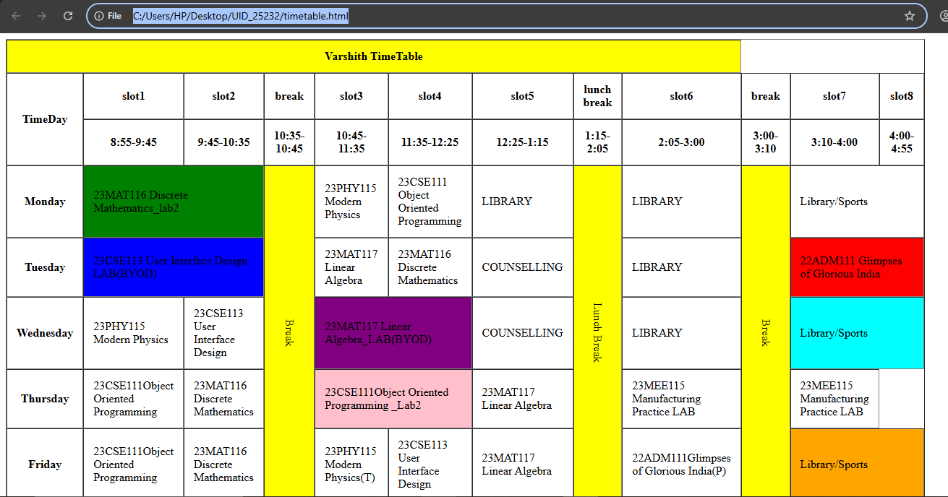
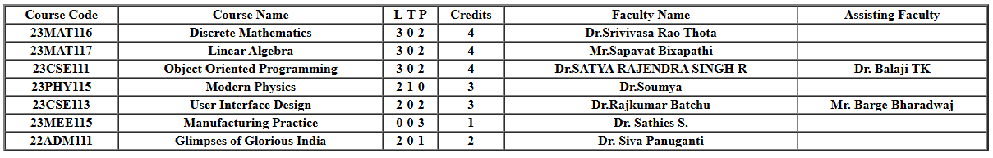
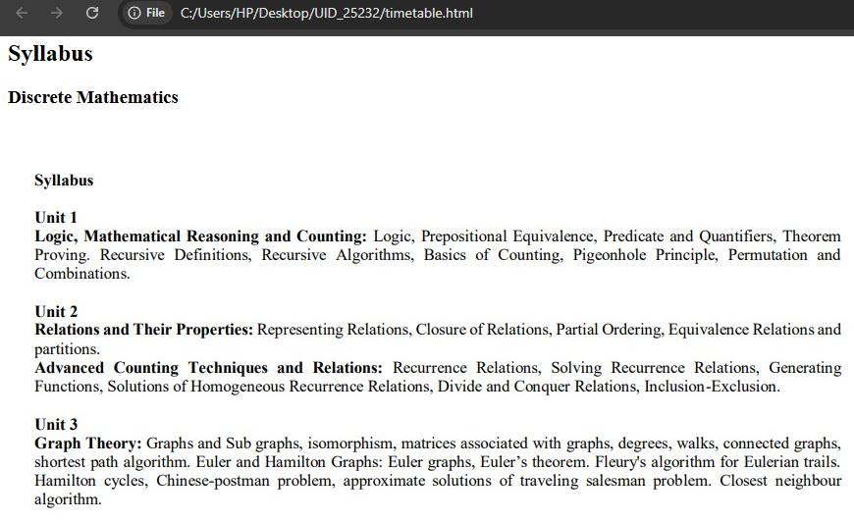

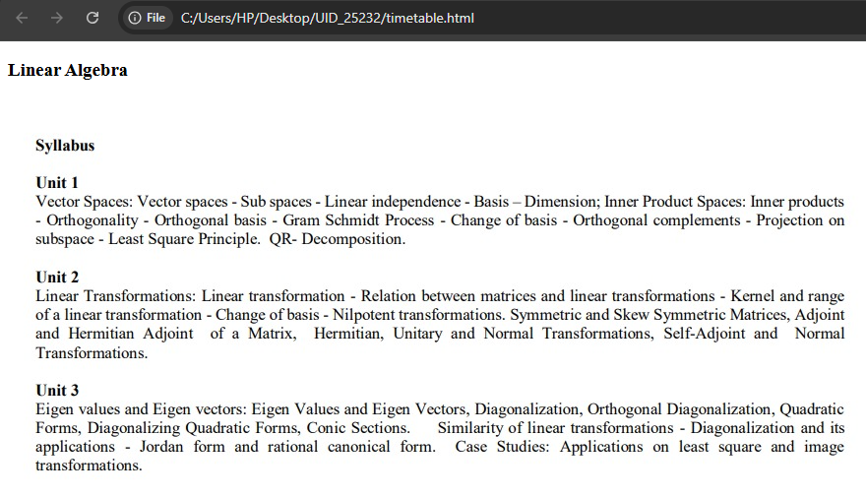
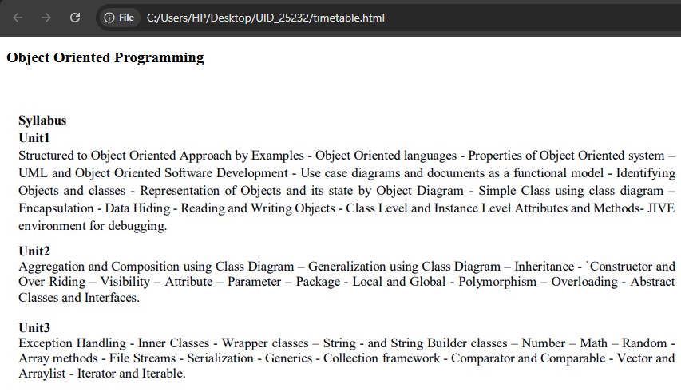
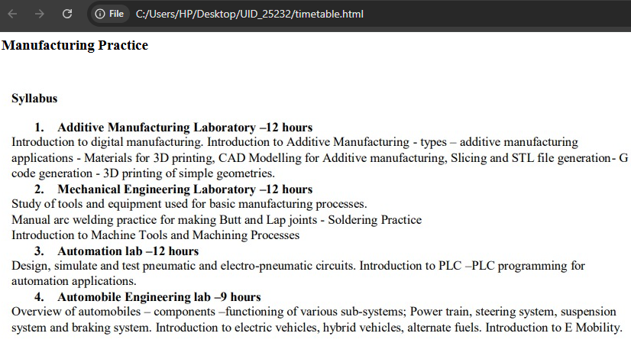
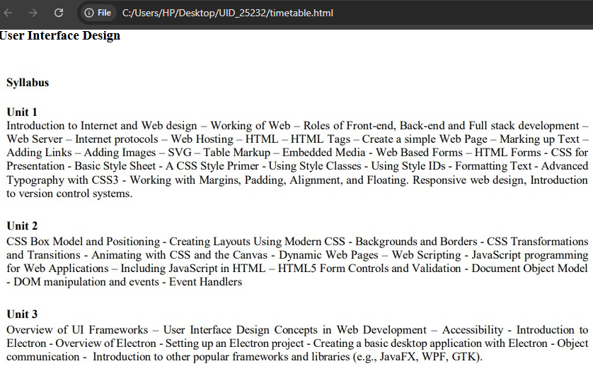
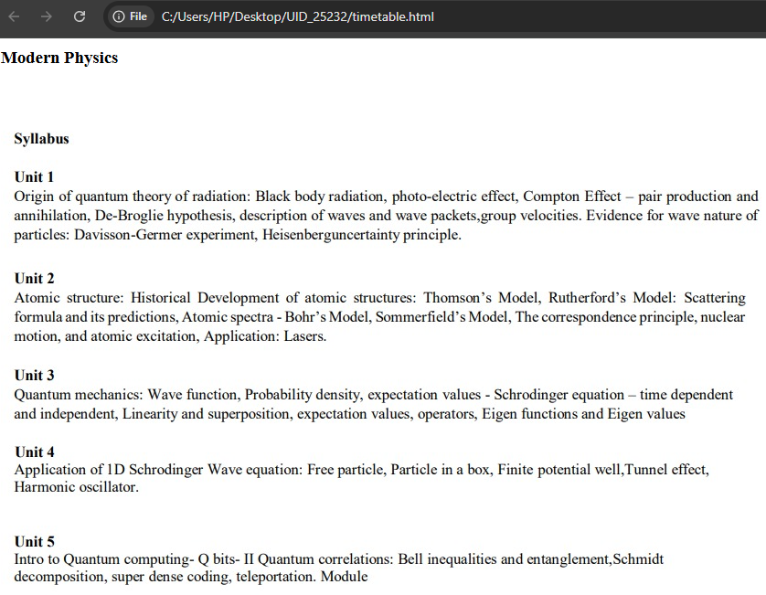
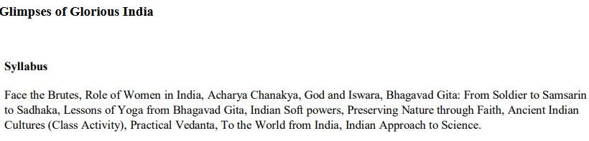

Explanation of Tables in HTML:-

Table Cells
Each table cell is defined by a <td> and a </td> tag.
td stands for table data.
Everything between <td> and </td> is the content of a table cell.

Table Rows
Each table row starts with a <tr> and ends with a </tr> tag.
tr stands for table row.

Table Headers
Sometimes you want your cells to be table header cells. In those cases use the <th> tag instead of the <td> tag.
th stands for table header.

Tag | Description
<table> | Defines a table
<th> | Defines a header cell in a table
<tr> | Defines a row in a table
<td> | Defines a cell in a table

HTML Table - Cell Padding
Cell padding is the space between the cell edges and the cell content.
By default the padding is set to 0.

HTML Table - Cell Spacing
Cell spacing is the space between each cell.
By default the space is set to 2 pixels.
HTML tables can have cells that span over multiple rows and/or columns.

HTML Table - Colspan
To make a cell span over multiple columns, use the colspan attribute.

HTML Table - Rowspan
To make a cell span over multiple rows, use the rowspan attribute.
WEEK-4
- Aim:-To design a college admission registration form using HTML tags.
Code:-
<!DOCTYPE html>
<html>
<head>
<title>College Admission Registration Form</title>
</head>
<body>
<h2 style="text-align: center;">Collge Admission Registration</h2>
<form>
<table border="1" cellpadding="8" cellspacing="0">
<tr>
<td><label for="fname">Full Name:</label></td>
<td><input type="text" id="fname" name="fname"></td>
</tr>
<tr>
<td><label for="email">Email:</label></td>
<td><input type="email" id="email" name="email"></td>
</tr>
<tr>
<td><label for="phone">Phone Number:</label></td>
<td><input type="number" id="phone" name="phone"></td>
</tr>
<tr>
<td>Gender:</td>
<td>
<input type="radio" id="male" name="gender">
<label for="male">Male</label>
<input type="radio" id="female" name="gender">
<label for="female">Female</label>
<input type="radio" id="other" name="gender">
<label for="other">Other</label>
</td>
</tr>
<tr>
<td><label for="course">Course Applying For:</label></td>
<td>
<select id="course" name="course">
<option>B.Tech</option>
<option>B.Sc</option>
<option>B.Com</option>
<option>BA</option>
<option>BBA</option>
</select>
</td>
</tr>
<tr>
<td>Hobbies:</td>
<td>
<input type="checkbox" id="sports">
<label for="sports">Sports</label>
<input type="checkbox" id="music">
<label for="music">Music</label>
<input type="checkbox" id="reading">
<label for="reading">Reading</label>
</td>
</tr>
<tr>
<td><label for="dob">Date of Birth:</label></td>
<td><input type="date" id="dob" name="dob"></td>
</tr>
<tr>
<td><label for="file">Upload Certificates:</label></td>
<td><input type="file" id="file" name="file"></td>
</tr>
<tr>
<td><label for="address">Address</label></td>
<td>
<textarea id="address" name="address" rows="5" cols="30"></textarea>
</td>
</tr>
<tr>
<td style="text-align: center;" colspan="2">
<input type="submit" value="Submit">
<input type="reset" value="Reset">
</td>
</tr>
</table>
</form>
</body>
</html>

Output:-
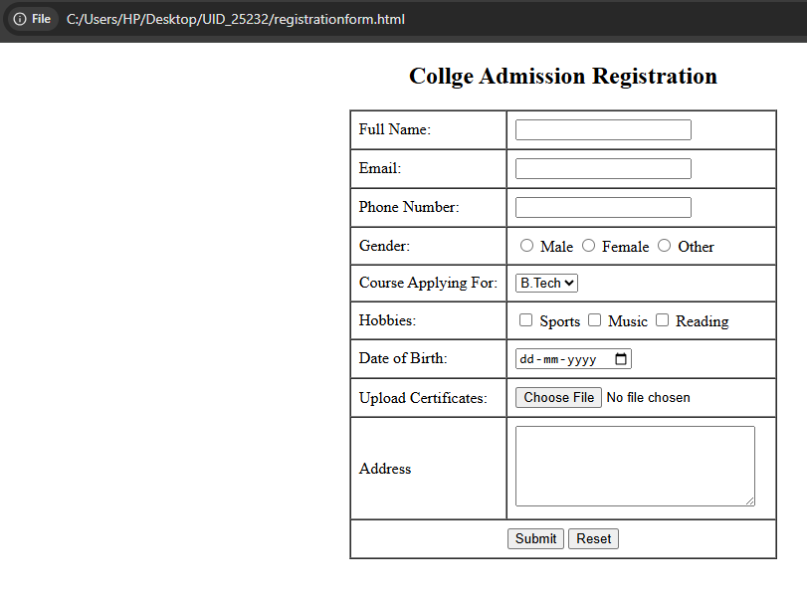
Explanation of tags:-
<form>:It is used to collect user input.
<label>:It provides a text description for input fields.
<input>:1.text – Normal text input.
2.email-E-mail format validation.
3.number-Only numbers allowed.
4.radio-Select one option.
5.checkbox-Select multiple options.
6.date-Date picker.
7.file-Upload files.
8.submit-Submit form.
9.reset-Clear form.
id:Unique element identifier.
name-Sends data to server.
2.Aim:- Create an HTML webpage displaying two forms using iframes.
Code:-
Login form
<!DOCTYPE html>
<html>
<body>
<h3 style="text-align: center;">User Login</h3>

<form>
<table border="1" cellpadding="8" cellspacing="0" align="center">
<tr>
<td>Username:</td>
<td><input type="text" name="username"></td>
</tr>
<tr>
<td>Password:</td>
<td><input type="password" name="password"></td>
</tr>
<tr>
<td colspan="2" style="text-align: center;">
<input type="submit" value="Login">
</td>
</tr>
</table>
</form>
</body>
</html>

Registration form
<!DOCTYPE html>
<html>
<body>
<h3 style="text-align: center;">User Registration</h3>
<form>
<table border="1" cellpadding="8" cellspacing="0" align="center">
<tr>
<td>Full Name:</td>
<td><input type="text" name="fname"></td>
</tr>
<tr>
<td>Email:</td>
<td><input type="email" name="email"></td>
</tr>
<tr>
<td>Phone:</td>
<td><input type="text" name="phone"></td>
</tr>
<tr>
<td>Password:</td>
<td><input type="password" name="password"></td>
</tr>
<tr>
<td colspan="2" style="text-align: center;">
<input type="submit" value="Submit">
<input type="reset" value="Reset">
</td>
</tr>
</table>
</form>
</body>
</html>

Two forms using iframes
<!DOCTYPE html>
<html>
<body style="background-color:aqua;">
<h2 style="text-align: center;">Two Forms Displayed Using Iframes</h2>
<table align="center">
<tr>
<td>
<iframe src="login.html" width="350" height="350">
</iframe>
</td>
<td>
<iframe src="registration.html" width="350" height="350">
</iframe>
</td>
</tr>
</table>
</body>
</html>

Output:-
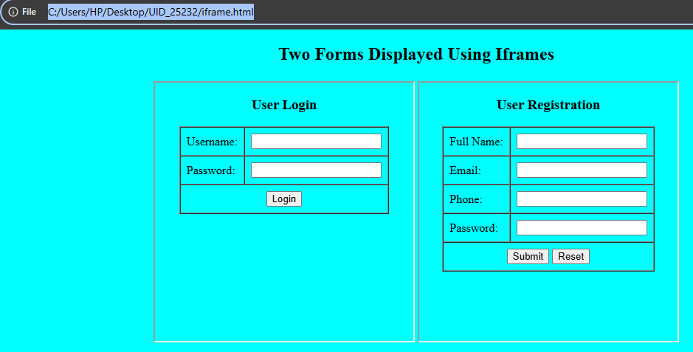

WEEK-5
5) a) Aim:- To display three different cards showing information in a HTML page.
Code:-
<!DOCTYPE html>
<html>
<head>
<title>Our Services</title>
</head>
<body>

<h1 style="text-align:center;">Our Services</h1>

<div style="text-align:center;">
<div style="width:250px; display:inline-block;
border:2px solid black;
border-radius:20px;
padding:20px;
margin:20px;">

<div style="height:120px;
border:2px solid black;
border-radius:15px;
margin-bottom:15px;">
</div>

<h3>Web Design</h3>
<p>Modern and responsive designs</p>

<a href="#"
style="display:inline-block;
margin-top:15px;
padding:8px 15px;
background-color:blue;
color:white;
text-decoration:none;
border-radius:5px;">
Learn More
</a>
</div>
<div style="width:250px; display:inline-block;
border:2px solid black;
border-radius:20px;
padding:20px;
margin:20px;">

<div style="height:120px;
border:2px solid black;
border-radius:15px;
margin-bottom:15px;">
</div>

<h3>Development</h3>
<p>Robust and scalable solutions</p>

<a href="#"
style="display:inline-block;
margin-top:15px;
padding:8px 15px;
background-color:blue;
color:white;
text-decoration:none;
border-radius:5px;">
Learn More
</a>
</div>
<div style="width:250px; display:inline-block;
border:2px solid black;
border-radius:20px;
padding:20px;
margin:20px;">

<div style="height:120px;
border:2px solid black;
border-radius:15px;
margin-bottom:15px;">
</div>

<h3>SEO</h3>
<p>Improve search engine ranking</p>

<a href="#"
style="display:inline-block;
margin-top:15px;
padding:8px 15px;
background-color:blue;
color:white;
text-decoration:none;
border-radius:5px;">
Learn More
</a>
</div>

</div>

</body>
</html>

Output:-
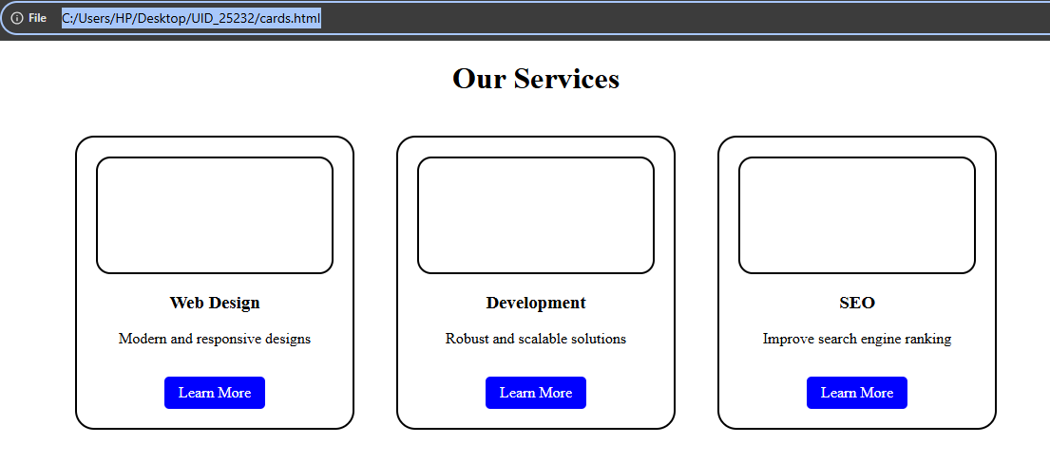

Explanation of tags:-
•<div> : It is used as a container for other HTML elements and comes with line breaks before and after.
•<button>: It creates a clickable button.
•.container: It is a CSS class selector used to apply styles to any HTML element that has class=”container”.
•.card: It is a CSS class selector used to style each individual card element.
•.card button: It is a CSS selector that styles the button inside the card.
•.card button-hover: It is a CSS pseudo-class that changes the button style when the mouse pointer moves over it.
•Display-flex: It uses flexbox layout.
•Flex-direction: It sets the display-direction of flex items.
•Flex-wrap: It specifies whether the flex items should wrap or not.
•Justify-content: It aligns the flex items when they do not use all available space on the main-axis (horizontally).
•Align-items: It aligns the flex items when they do not use all available space on the cross-axis (vertically).
•box-shadow: It adds shadow effect.
b)Aim:-Create three basic web pages like index.html,home.html,about.html,contact.html.Upon clicking on home,about,contact the content should display in the same page.
Code:-
index.html
<!DOCTYPE html>
<html>
<head>
<title>Navigation Using iFrame</title>
</head>

<body>
<h2>Navigation Menu</h2>

<a href="home.html" target="content">Home</a> |
<a href="about.html" target="content">About</a> |
<a href="contact.html" target="content">Contact</a>

<hr>

<iframe name="content"
src="home.html"
width="100%"
height="400px"
style="border:1px solid black;">
</iframe>

</body>
</html>
home.html
<!DOCTYPE html>
<html>
<head>
<title>Home</title>
</head>
<body>

<h1>Welcome to Home Page</h1>
<p>This is the Home page content.</p>

</body>
</html>
about.html
<!DOCTYPE html>
<html>
<head>
<title>About</title>
</head>
<body>

<h1>About Us</h1>
<p>This is the About page content.</p>

</body>
</html>
contact.html
<!DOCTYPE html>
<html>
<head>
<title>Contact</title>
</head>
<body>

<h1>Contact Us</h1>
<p>Email: example@gmail.com</p>
<p>Phone: 9876543210</p>

</body>
</html>

Output:-
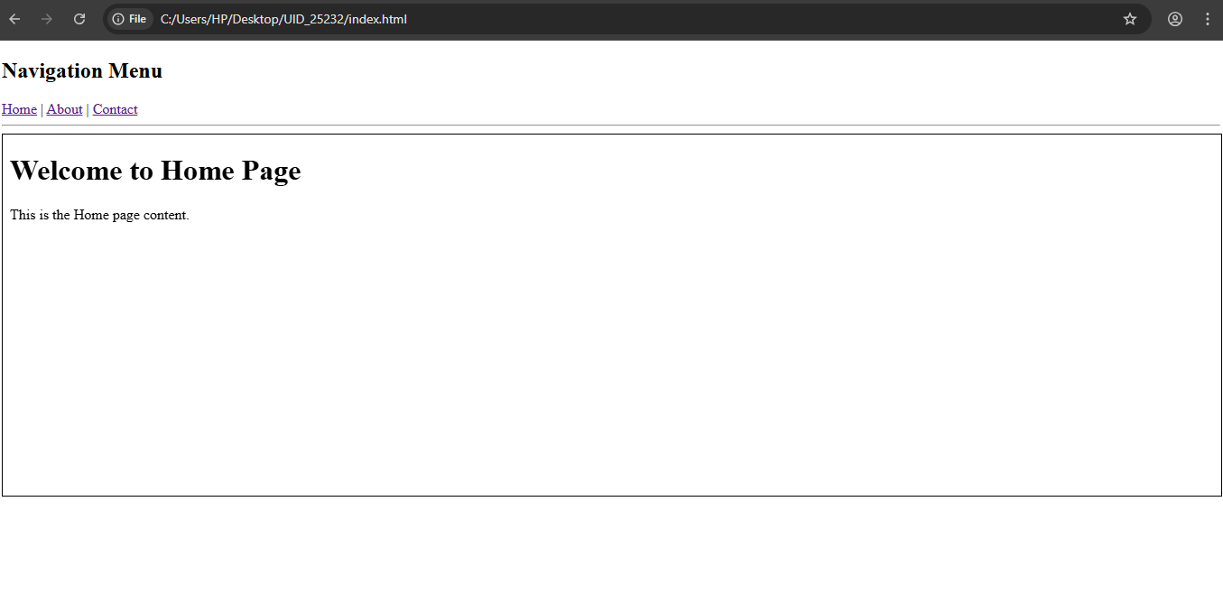
Upon clicking Home option it displays the above content.
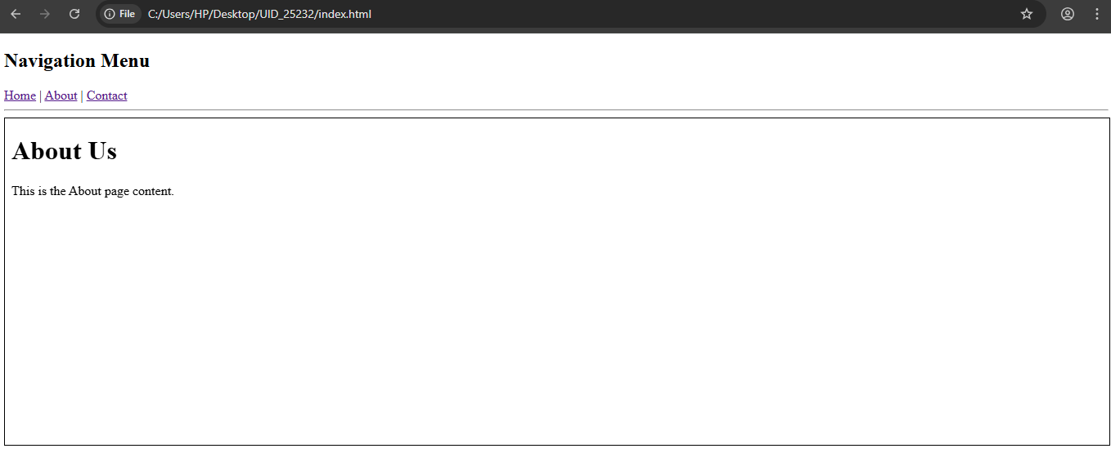
Upon clicking About option it displays the above content.

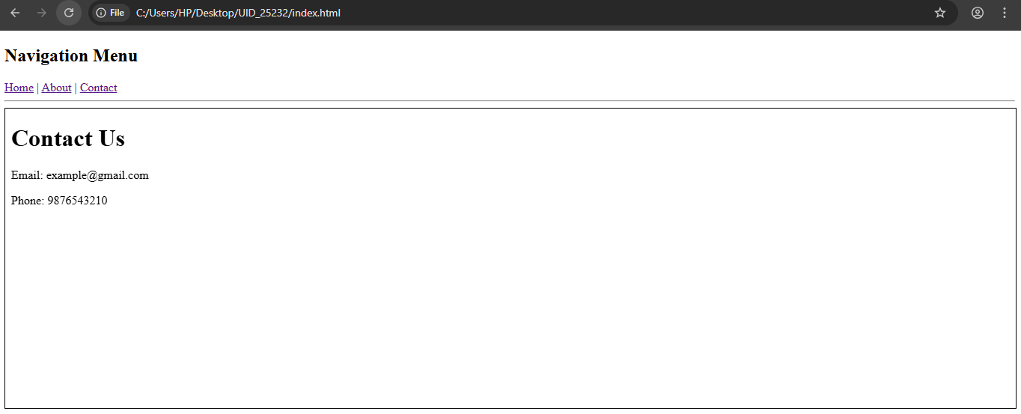
Upon clicking on Contact option the page navigates to contact page.
Explanation of tags:-
1)<a>: It creates links (navigation buttons).
2)href: It creates page links.
3)Target attribute: It specifies where to open the linked document.
4)<div> : It is used as a container for other HTML elements and comes with line breaks before and after.
5)<iframe>:An HTML iframe is used to display a web page within a web page.
5.c)Aim:-To design Amrita login page by displaying different campuses on the homepage.Upon clicking on each Campus the details about the campus should be displayed on the same page.Use HTML and CSS to design stylish webpage.
Code:-
<!DOCTYPE html>
<html>
<head>
<title>Amrita Vishwa Vidyapeetham</title>
<style>

body{
margin:0;
font-family:Arial;
background-image:url("background.jpg");
background-size:cover;
}
.header{
background:#8b0000;
color:white;
text-align:center;
font-size:40px;
padding:12px;
font-weight:bold;
}
.menu{
background:#1f6fb2;
text-align:center;
padding:10px;
}

.menu a{
color:yellow;
margin:12px;
font-size:18px;
text-decoration:none;
font-weight:bold;
}

.menu a:hover{
text-decoration:underline;
}
.container{
display:flex;
padding:40px;
}
.login{
width:280px;
padding:20px;
background:linear-gradient(135deg,#2c3e50,#27ae60);
border-radius:10px;
color:white;
}

.login h2{
text-align:center;
}

input{
width:100%;
padding:8px;
margin:10px 0;
border:none;
border-radius:5px;
}

button{
width:100%;
padding:8px;
background:#0d6efd;
border:none;
color:white;
border-radius:5px;
}
.info{
flex:1;
margin-left:40px;
background:white;
padding:25px;
border-radius:10px;
}
.campus{
display:none;
}
#home{
display:block;
}
:target{
display:block;
}

img{
width:350px;
margin-top:15px;
border-radius:10px;
}

</style>

</head>

<body>

<div class="header">
AMRITA VISHWA VIDHYAPEETHAM
</div>

<div class="menu">
<a href="#amaravati">AMARAVATI</a>
<a href="#amritapuri">AMRITAPURI</a>
<a href="#bengaluru">BENGALURU</a>
<a href="#chennai">CHENNAI</a>
<a href="#coimbatore">COIMBATORE</a>
</div>

<div class="container">
<div class="login">
<h2>Login</h2>
<input type="text" placeholder="Enter your email">
<input type="password" placeholder="Enter your password">
<label>
<input type="checkbox"> Save me
</label>
<br><br>
<button>Login</button>
<p><a href="#" style="color:lightblue;">Forgot Password?</a></p>
<p>Don't have an account?
<a href="#" style="color:yellow;">Register</a></p>
</div>
<div class="info">
<div id="home" class="campus">
<h2>About the Campus</h2>
<p>Click on a campus above to view its details.</p>
</div>

<div id="amaravati" class="campus">
<h2>Amaravati Campus</h2>
<p>Amrita Amaravati campus is located near the Krishna River and focuses on research and sustainability.</p>
<img src="amaravati.jpg">
</div>

<div id="amritapuri" class="campus">
<h2>Amritapuri Campus</h2>
<p>Amritapuri campus is the headquarters of Amrita University and located in Kerala.</p>
<img src="amritapuri.jpg">
</div>

<div id="bengaluru" class="campus">
<h2>Bengaluru Campus</h2>
<p>Bengaluru campus focuses on AI, robotics and advanced engineering programs.</p>
<img src="bengaluru.jpg">
</div>

<div id="chennai" class="campus">
<h2>Chennai Campus</h2>
<p>Chennai campus provides programs in computer science, electronics and mechanical engineering.</p>
<img src="chennai.jpg">
</div>

<div id="coimbatore" class="campus">
<h2>Coimbatore Campus</h2>
<p>Coimbatore campus is the largest campus offering engineering, medicine and research facilities.</p>
<img src="coimbatore.jpg">
</div>

</div>

</div>

</body>
</html>
Output:-
Upon clicking amaravati the page is displayed
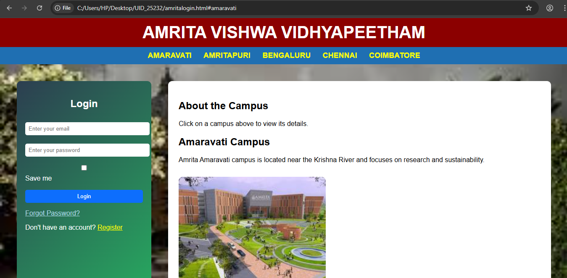
Upon clicking amritapuri the page is displayed
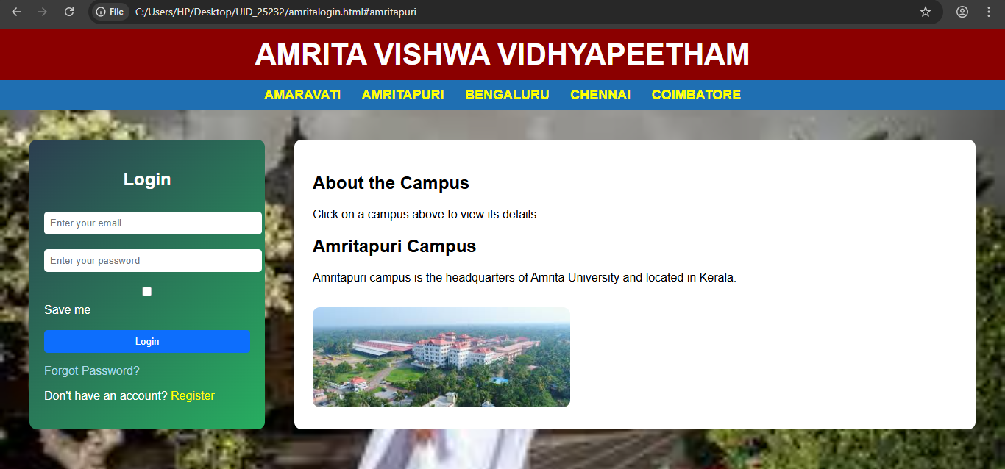

Upon clicking bengaluru the page is displayed
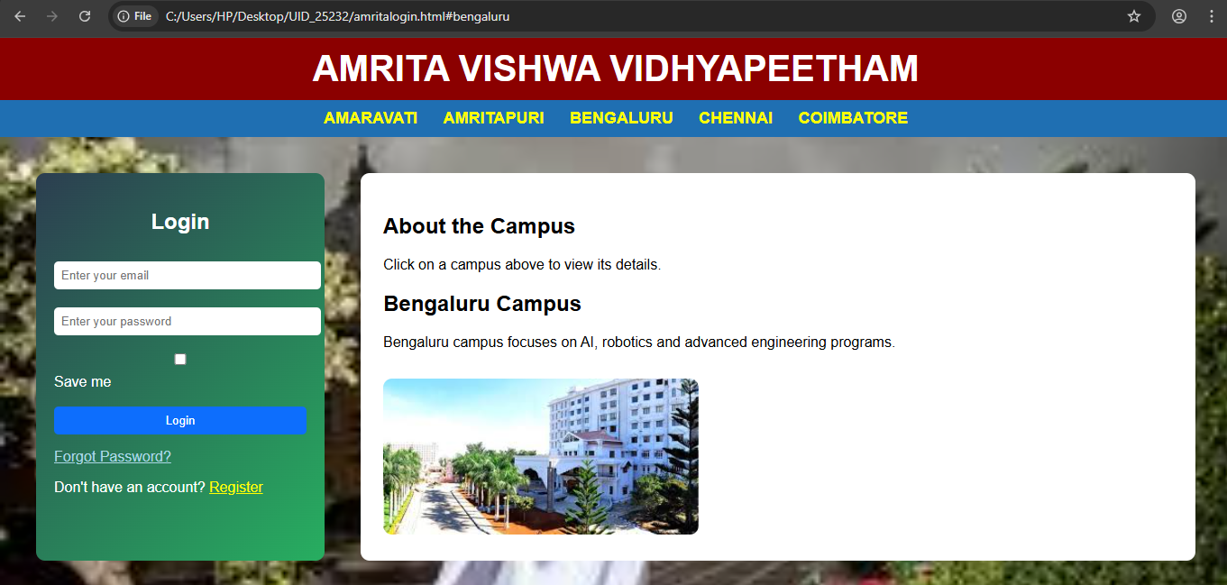

Upon clicking chennai the page is displayed
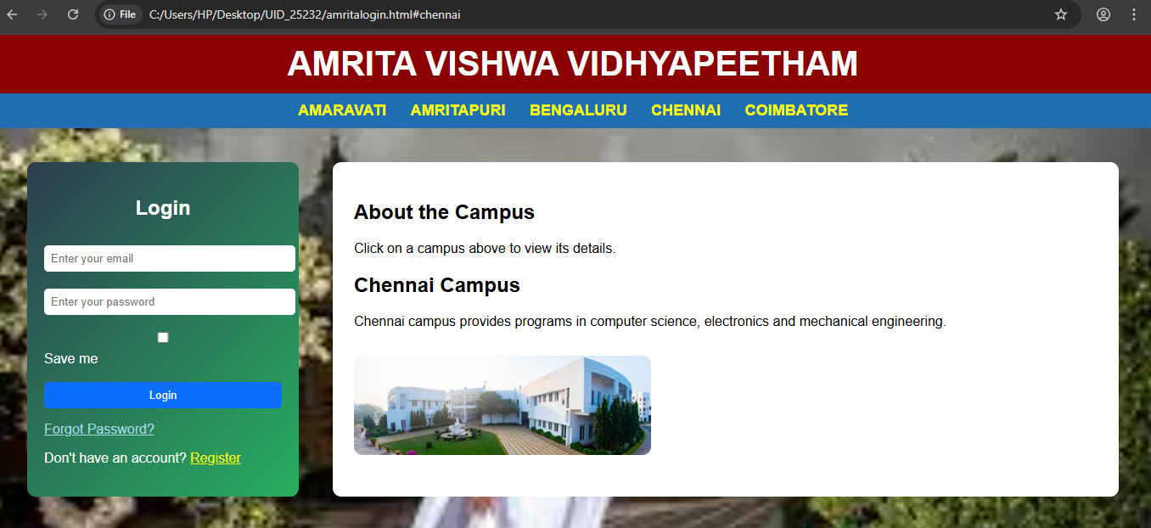

Upon clicking coimbatore the page is displayed
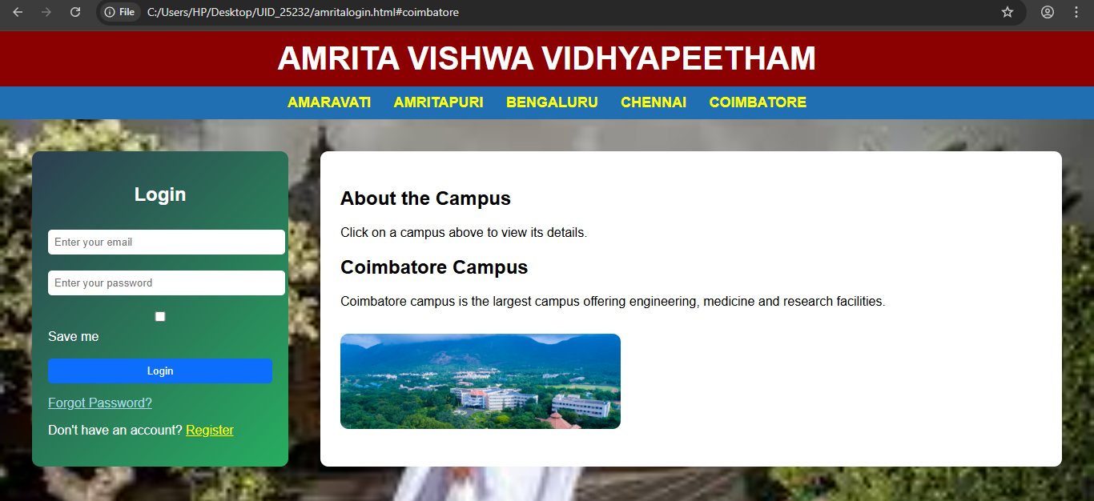
Explanation of Tags:-
1)<style>: It is used to write CSS styles for designing the webpage.
2)<a>: It creates links (navigation buttons).
2)href: It creates page links.
3)Target attribute: It specifies where to open the linked document.
4)<input type="checkbox"> : Checkboxes are used to select one or more options of a limited number of choices.
5)<input type=”submit”>: It defines a submit button which submits all form values to a form-handler..
6) <div> : It is used as a container for other HTML elements and comes with line breaks before and after.
7)<label>: It displays text describing an input field.
8)<iframe>:An HTML iframe is used to display a web page within a web page.
9)CSS Flexbox Layout: It is a layout model for arranging items (horizontally or vertically) within a container, in a flexible and responsive way.

WEEK-6
Aim:-To design a responsive e-commerce application using the grid layout. This application should contain different categories of products such as electronics, clothing, home-appliances, books. Based on the category we select corresponding products should be displayed on the sidebar.
Code:-
<!DOCTYPE html>
<html>
<head>
<title>E-Commerce Store</title>
<style>
body{
font-family:Arial;
margin:0;
}
.container{
display:grid;
grid-template-columns:220px 1fr;
grid-template-areas:
"header header"
"sale sale"
"sidebar products"
"footer footer";
}
.header{
grid-area:header;
background:aquamarine;
padding:20px;
text-align:center;
font-size:28px;
}
.sale{
grid-area:sale;
background:blueviolet;
color:white;
padding:15px;
text-align:center;
}
.sidebar{
grid-area:sidebar;
background:#f4f4f4;
padding:20px;
}

.sidebar label{
display:block;
padding:8px;
cursor:pointer;
background:white;
margin-bottom:10px;
border-radius:5px;
}

.sidebar label:hover{
background:lightblue;
}

.products{
grid-area:products;
padding:20px;
display:grid;
grid-template-columns:repeat(auto-fit,minmax(220px,1fr));
gap:20px;
}

.card{
border:1px solid #ccc;
padding:15px;
text-align:center;
border-radius:10px;
background:white;
display:none;
}
.card img{
width:100%;
height:140px;
object-fit:contain;
background:#f2f2f2;
padding:10px;
}

.price{
color:green;
font-weight:bold;
}

button{
background:orange;
border:none;
padding:8px 12px;
color:white;
border-radius:5px;
cursor:pointer;
}

button:hover{
background:red;
}

input{
display:none;
}

#electronics:checked ~ .container .electronics,
#clothing:checked ~ .container .clothing,
#home:checked ~ .container .home,
#books:checked ~ .container .books{
display:block;
}

#all:checked ~ .container .card{
display:block;
}

.footer{
grid-area:footer;
background:black;
color:white;
text-align:center;
padding:15px;
}

@media(max-width:768px){
.container{
grid-template-columns:1fr;
grid-template-areas:
"header"
"sale"
"sidebar"
"products"
"footer";
}
}

</style>
</head>

<body>

<input type="radio" name="cat" id="all" checked>
<input type="radio" name="cat" id="electronics">
<input type="radio" name="cat" id="clothing">
<input type="radio" name="cat" id="home">
<input type="radio" name="cat" id="books">

<div class="container">

<div class="header">My E-Commerce Store</div>
<div class="sale">🔥 Mega Sale Up To 50% Off 🔥</div>

<div class="sidebar">
<h3>Categories</h3>
<label for="all">All</label>
<label for="electronics">Electronics</label>
<label for="clothing">Clothing</label>
<label for="home">Home Appliances</label>
<label for="books">Books</label>
</div>

<div class="products">

<div class="card electronics">
<img src="C:\Users\HP\Desktop\UID_25232\mobile.jpg">
<h4>iPhone 17</h4>
<p class="price">₹40000</p>
<button>Add to Cart</button>
</div>

<div class="card electronics">
<img src="C:\Users\HP\Desktop\UID_25232\laptop.jpg">
<h4>MacBook Air M5</h4>
<p class="price">₹55000</p>
<button>Add to Cart</button>
</div>

<div class="card clothing">
<img src="C:\Users\HP\Desktop\UID_25232\T-shirt.jpg">
<h4>T-Shirt</h4>
<p class="price">₹799</p>
<button>Add to Cart</button>
</div>

<div class="card clothing">
<img src="C:\Users\HP\Desktop\UID_25232\jeans.jpg">
<h4>Jeans</h4>
<p class="price">₹1299</p>
<button>Add to Cart</button>
</div>

<div class="card home">
<img src="C:\Users\HP\Desktop\UID_25232\washingmachine.jpg">
<h4>Washing Machine</h4>
<p class="price">₹22000</p>
<button>Add to Cart</button>
</div>

<div class="card books">
<img src="C:\Users\HP\Desktop\UID_25232\java.jpg">
<h4>Java Programming</h4>
<p class="price">₹499</p>
<button>Add to Cart</button>
</div>

</div>

<div class="footer">© copyright 2026 My Store</div>

</div>

</body>
</html>

Output:-
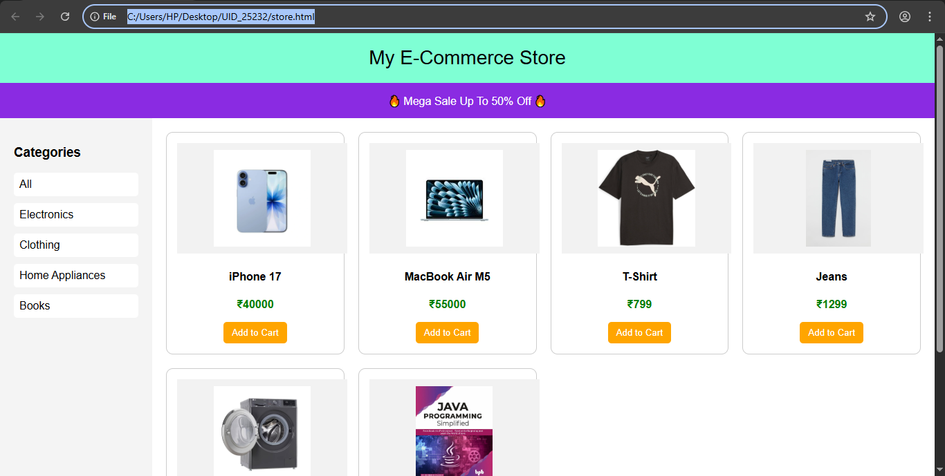
If we click on electronics category then the output displayed is
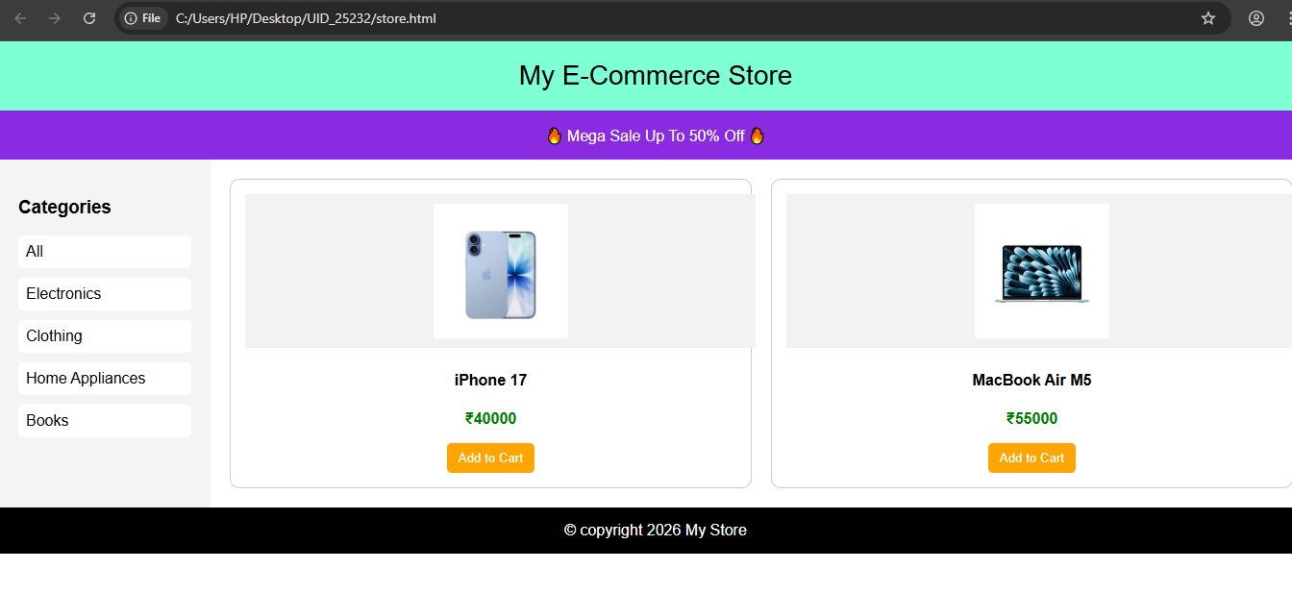

If we click on clothing category then the output displayed is
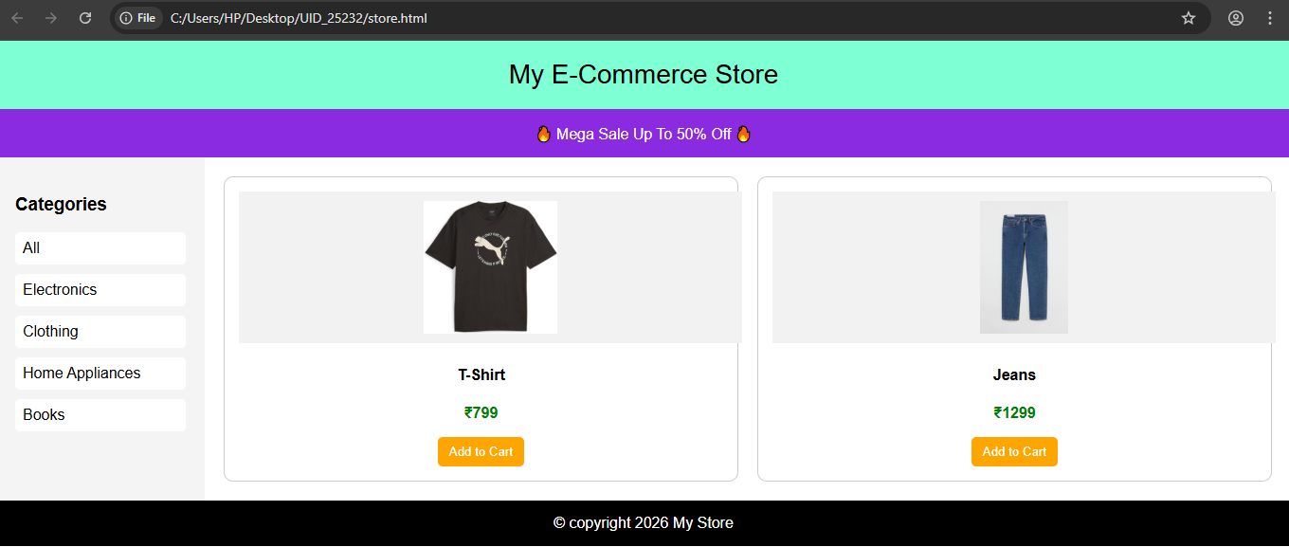
If we click on home appliances category then the output displayed is
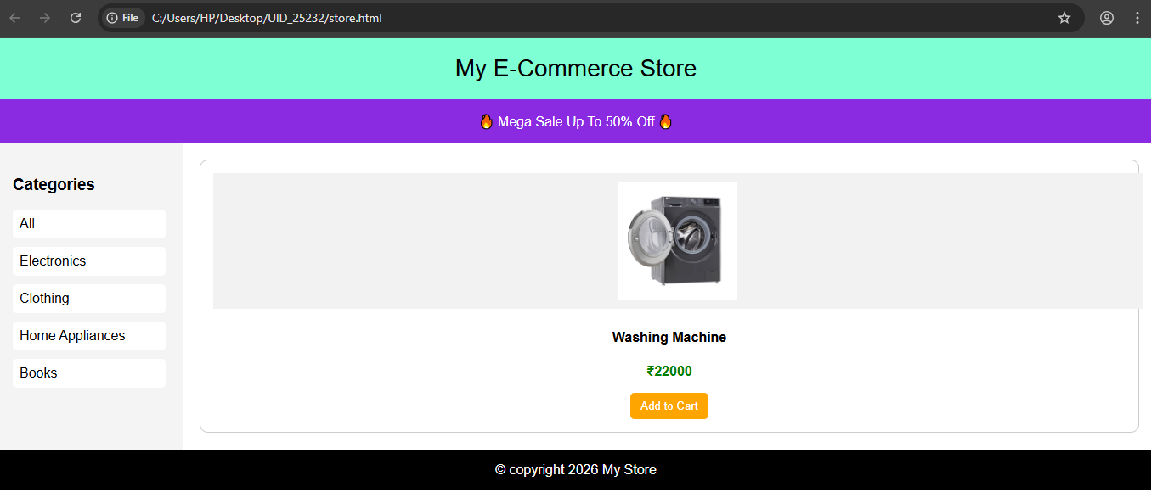

If we click on Books category then the output displayed is
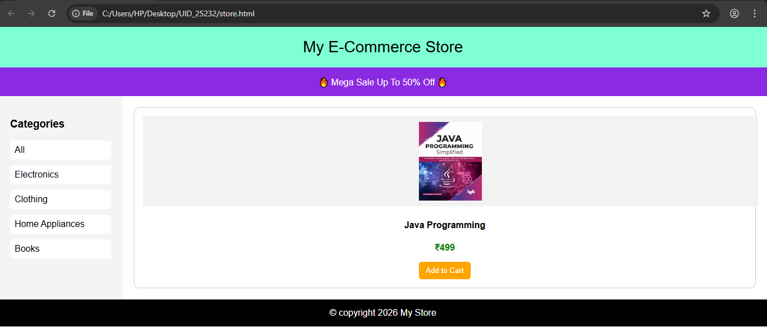

Explanation of tags and attributes used in the code:-
display:grid;
grid-template-areas
àUsed to create responsive layout like real e-commerce sites.
button:hover
à Changes button color when mouse is over it.
.container{
display:grid;
}
• Controls full page layout
• Divides page into rows & columns.
.header{
background:aquamarine;
Represents top section of website.
Shows store title.
.sale
Represents offer banner section.
.sidebar
Contains:
- Electronics
- Clothing
- Home appliances
- Books
.products
Uses grid to arrange product cards.
.card
Each product box is called card.
Contains:
- Image
- Product name
- Price
- Button
.price
Used to style product price.
.footer
Bottom section of website.

WEEK-7
7.A) Aim: create a GitHub account and create a repository in it and push all the week 6 code files in it.
Procedure:
- Go to the GitHub website: https://github.com
- Sign up and create a new GitHub account.
- After login, click on “New Repository”.
- Enter repository name and click Create Repository.
- Open Git Bash / Terminal on your system.
- Navigate to your Week-6 project folder.
- Initialize Git:
git init
- Add files:
git add .
- Commit files:
git commit -m "Week 6 code upload"
- Connect to GitHub repository:
git remote add origin <repository_link>
- Push files:
git push -u origin main

Procedure:
- Go to the GitHub website: https://github.com
- Sign up and create a new GitHub account.
- After login, click on “New Repository”.
- Enter repository name and click Create Repository.
- Open Git Bash / Terminal on your system.
- Navigate to your Week-6 project folder.
- Initialize Git:
git init
- Add files:
git add .
- Commit files:
git commit -m "Week 6 code upload"
- Connect to GitHub repository:
git remote add origin <repository_link>
- Push files:
git push -u origin main

output:
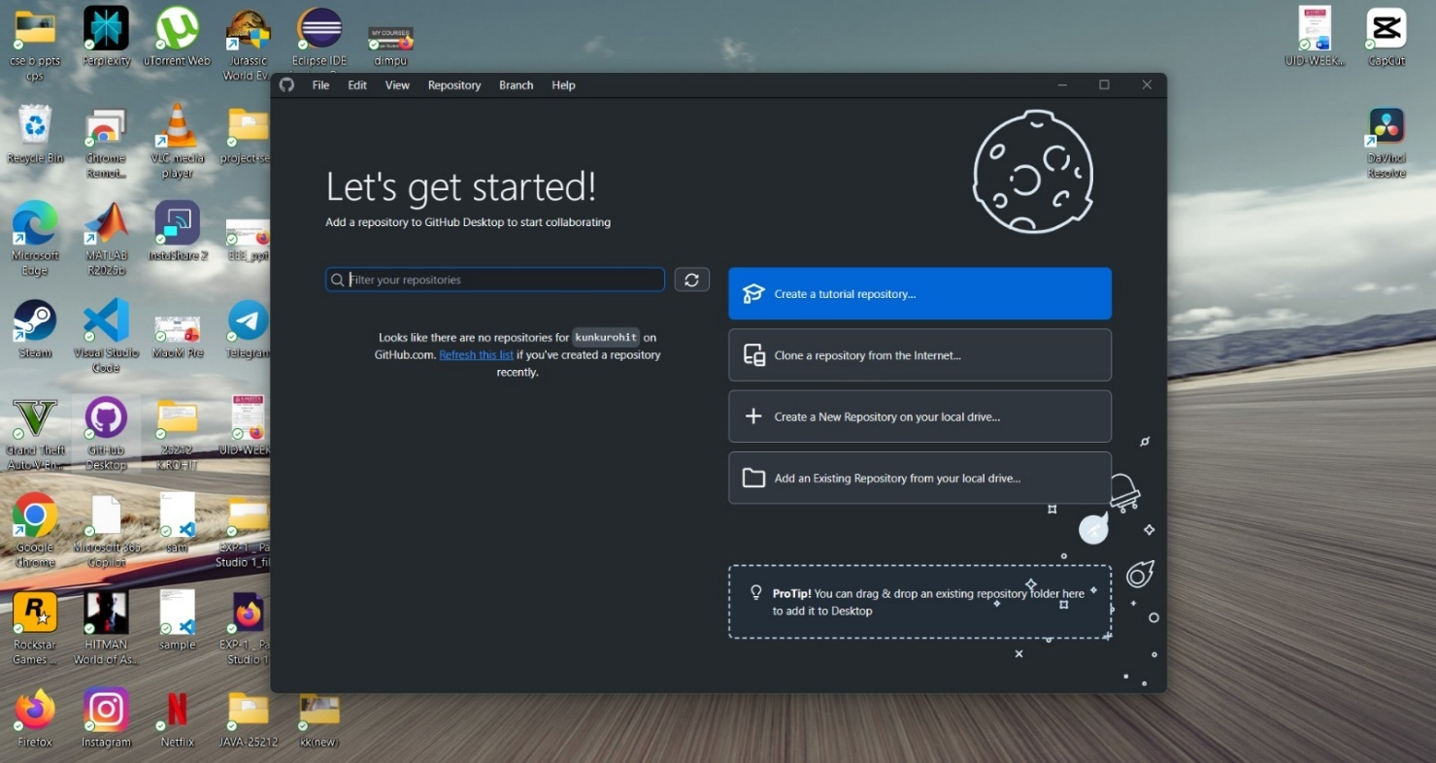
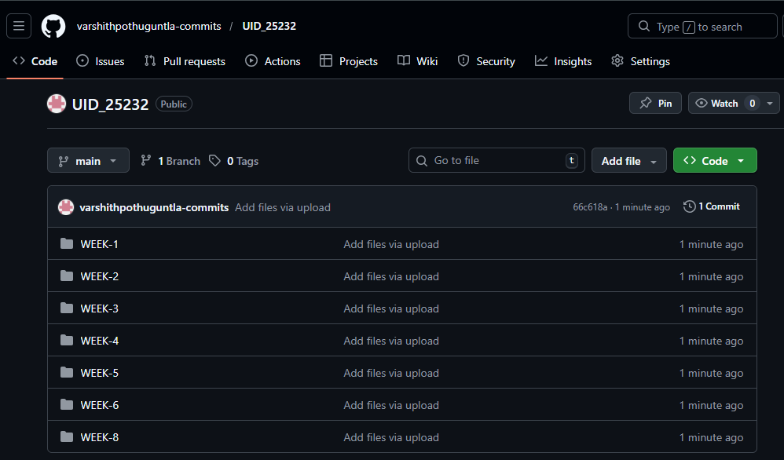
Link for repository:
https://github.com/varshithpothuguntla-commits/UID_25232

WEEK-8
1.Aim:-To create a webpage that displays a square that continuously rotates 360 using CSS animations.
Code:-
<!DOCTYPE html>
<html>
<head>
<title>Rotating Square</title>
<style>
body {
display: flex;
justify-content: center;
align-items: center;
height: 100vh;
background-color: #f0f0f0;
}

.square {
width: 150px;
height: 150px;
background-color: teal;
animation: rotateSquare 2s linear infinite;
}
@keyframes rotateSquare {
from {
transform: rotate(0deg);
}
to {
transform: rotate(360deg);
}
}
</style>
</head>
<body>

<div class="square"></div>

</body>
</html>

Output:-
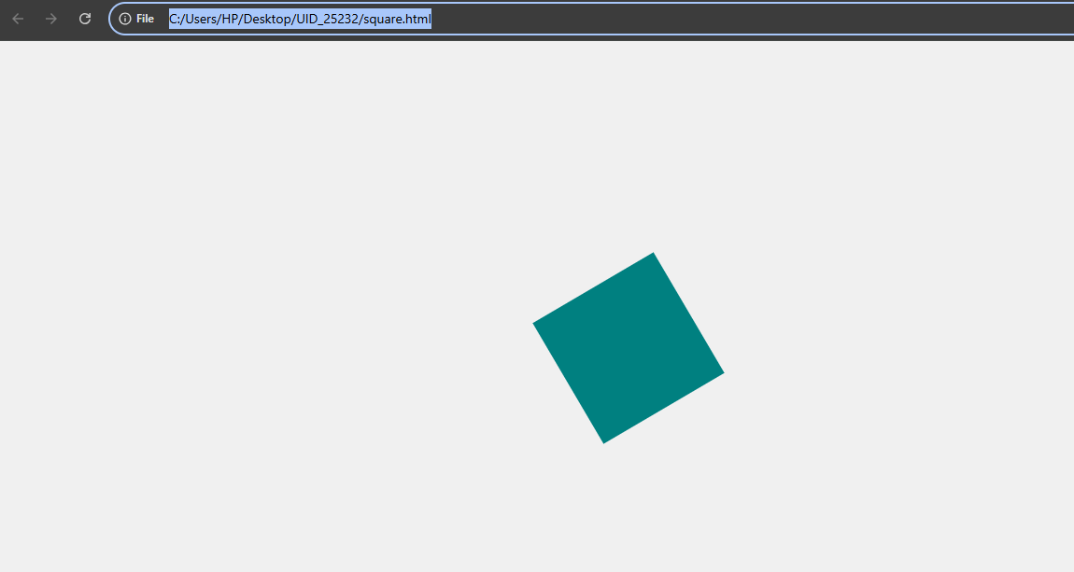
2.Aim:- To create a ball that moves up and down continuously using CSS animation.
Code:-
<!DOCTYPE html>
<html>
<head>
<title>Bouncing Ball</title>
<style>
body {
display: flex;
justify-content: center;
align-items: center;
height: 100vh;
background-color: #f0f0f0;
}

.ball {
width: 80px;
height: 80px;
background-color: crimson;
border-radius: 50%;
animation: bounce 1s ease-in-out infinite;
}
@keyframes bounce {
0% {
transform: translateY(0);
}
50% {
transform: translateY(-150px);
}
100% {
transform: translateY(0);
}
}
</style>
</head>
<body>

<div class="ball"></div>

</body>
</html>
Output:-
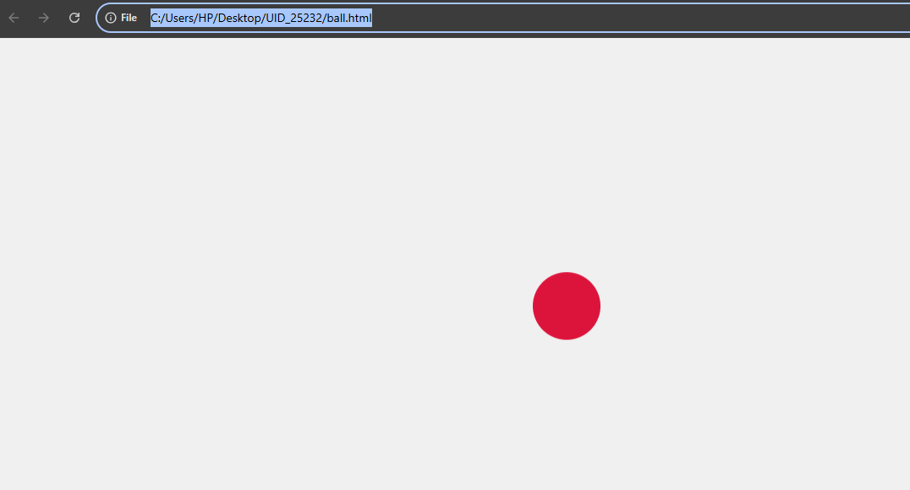

3.Aim:- To create a circle that moves horizontally and rotates at the same time.
Code:-
<!DOCTYPE html>
<html>
<head>
<title>Moving & Rotating Circle</title>
<style>
body {
height: 100vh;
margin: 0;
display: flex;
align-items: center;
background-color: #f0f0f0;
overflow: hidden;
}

.circle {
width: 80px;
height: 80px;
background-color: royalblue;
border-radius: 50%;
animation: moveRotate 3s linear infinite;
}
@keyframes moveRotate {
0% {
transform: translateX(0) rotate(0deg);
}
50% {
transform: translateX(300px) rotate(180deg);
}
100% {
transform: translateX(600px) rotate(360deg);
}
}
</style>
</head>
<body>

<div class="circle"></div>

</body>
</html>

Output:-
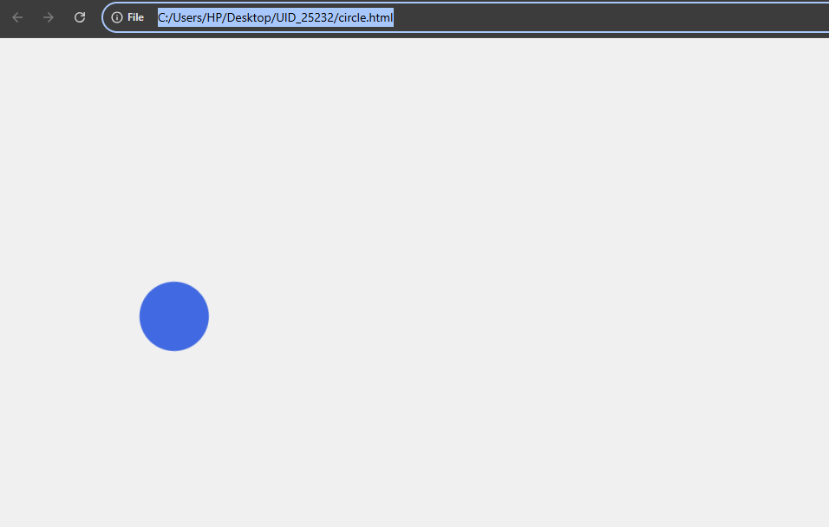
Explanation of tags and attributes:-
display: flex;
Enables Flexbox layout
justify-content: center;
Aligns items horizontally (center)
align-items: center;
- Aligns items vertically (center)
height: 100vh;
- Sets height to 100% of screen (viewport height)
margin: 0;
- Removes default spacing around body

overflow: hidden;
- Hides anything going outside the screen

Styling Properties
width and height
- Define size of shapes
width: 150px;
height: 150px;
background-color
- Sets color of element
background-color: teal;
border-radius: 50%;
- Makes a square into a circle

Animation Properties
animation
Shortcut property that combines:
animation: name duration timing-function iteration-count;
Example:
animation: bounce 1s ease-in-out infinite;
- bounce → animation name
- 1s → duration
- ease-in-out → speed pattern
- infinite → repeat forever
@keyframes
- Defines the animation steps
Example:
@keyframes bounce {
0% { transform: translateY(0); }
50% { transform: translateY(-150px); }
100% { transform: translateY(0); }
}

Transform Function
transform
Used to apply movement or rotation
rotate(deg)
- Rotates element
rotate(360deg)
translateX(px)
Moves element left to right
translateY(px)
- Moves element up to down
- Negative value = move up
Combined transform
transform: translateX(300px) rotate(180deg);
Moves AND rotates at the same time

Timing Functions

linear
- Same speed throughout

Ease-in-out
- Slow → fast → slow (smooth motion)

Iteration

infinite
- Animation runs forever

alternate
- Moves forward then backward
animation: moveRotate 3s linear infinite alternate;

WEEK – 9
Aim:- Create an webpage using html, CSS, java script based on the given conditions:
a)Create a button for each program, based on the button clicked the corresponding program has to be executed and should display the output.
b)The logics for each button includes finding an even numbers, odd number, prime or not, factorial of a number, amstrong or not.
c)Use appropriate designs to display the output.

Code:-
<!DOCTYPE html>
<html>
<head>
<title>Number Operations</title>

<style>
body {
font-family: Arial;
background: linear-gradient(135deg, #667eea, #764ba2);
display: flex;
justify-content: center;
align-items: center;
height: 100vh;
margin: 0;
}

.container {
background: white;
padding: 30px;
border-radius: 15px;
text-align: center;
box-shadow: 0 10px 25px rgba(0,0,0,0.2);
width: 350px;
}

h2 {
margin-bottom: 20px;
}

input {
padding: 10px;
width: 80%;
border-radius: 8px;
border: 2px solid #667eea;
margin-bottom: 15px;
font-size: 16px;
}

button {
margin: 5px;
padding: 10px 15px;
border: none;
border-radius: 8px;
background: #667eea;
color: white;
cursor: pointer;
transition: 0.3s;
}

button:hover {
background: #5a67d8;
}

#result {
margin-top: 15px;
font-size: 18px;
font-weight: bold;
color: #333;
}
</style>

<script>
function checkEvenOdd() {
let a = document.getElementById("num").value;
if (a % 2 == 0) {
result.innerHTML = a + " is Even Number";
} else {
result.innerHTML = a + " is Odd Number";
}
}

function checkPrime() {
let n = document.getElementById("num").value;
let count = 0;

for (let i = 1; i <= n; i++) {
if (n % i == 0) count++;
}

if (count == 2)
result.innerHTML = n + " is Prime Number";
else
result.innerHTML = n + " is Not Prime Number";
}

function factorial() {
let n = document.getElementById("num").value;
let k = 1;

for (let i = 1; i <= n; i++) {
k *= i;
}

result.innerHTML = "Factorial is " + k;
}

function armstrong() {
let n = document.getElementById("num").value;
let temp = n;
let sum = 0;

while (n > 0) {
let r = n % 10;
sum += r * r * r;
n = Math.floor(n / 10);
}

if (sum == temp)
result.innerHTML = temp + " is Armstrong Number";
else
result.innerHTML = temp + " is Not Armstrong Number";
}
</script>

</head>

<body>

<div class="container">
<h2>Number Operations</h2>

<input type="number" id="num" placeholder="Enter a number">

<br>

<button onclick="checkEvenOdd()">Even / Odd</button>
<button onclick="checkPrime()">Prime</button>
<button onclick="factorial()">Factorial</button>
<button onclick="armstrong()">Armstrong</button>

<p id="result"></p>
</div>

</body>
</html>

Output:-
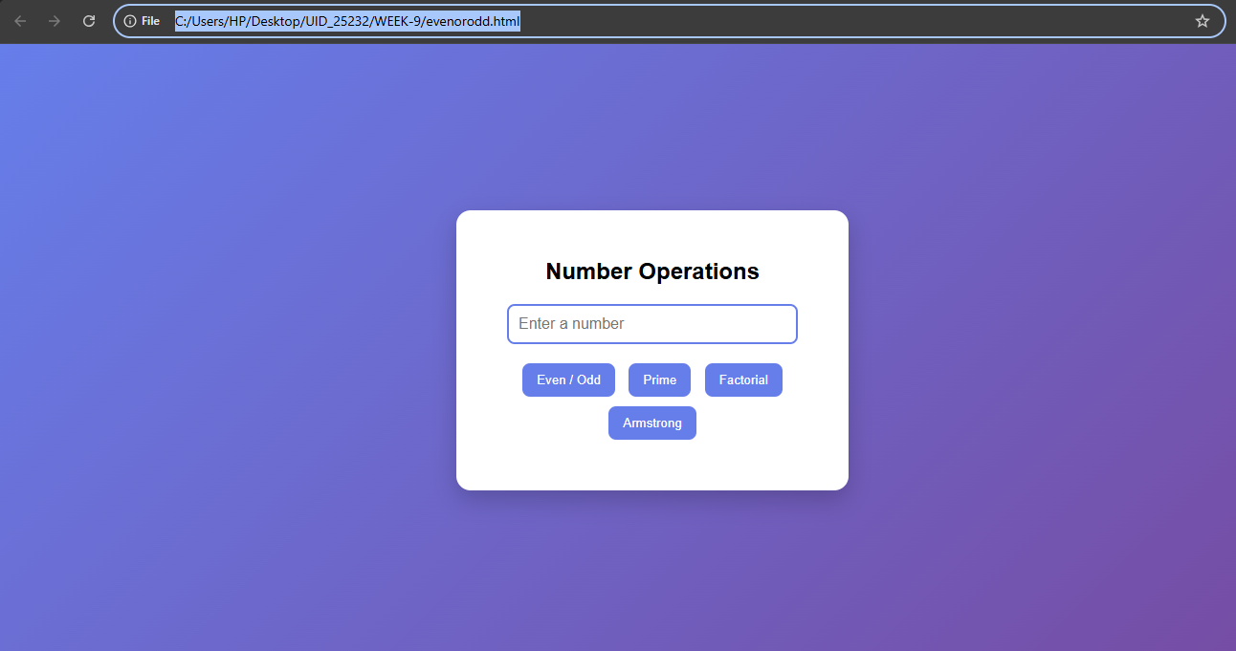

If number = 153 then the output is
For even/odd:
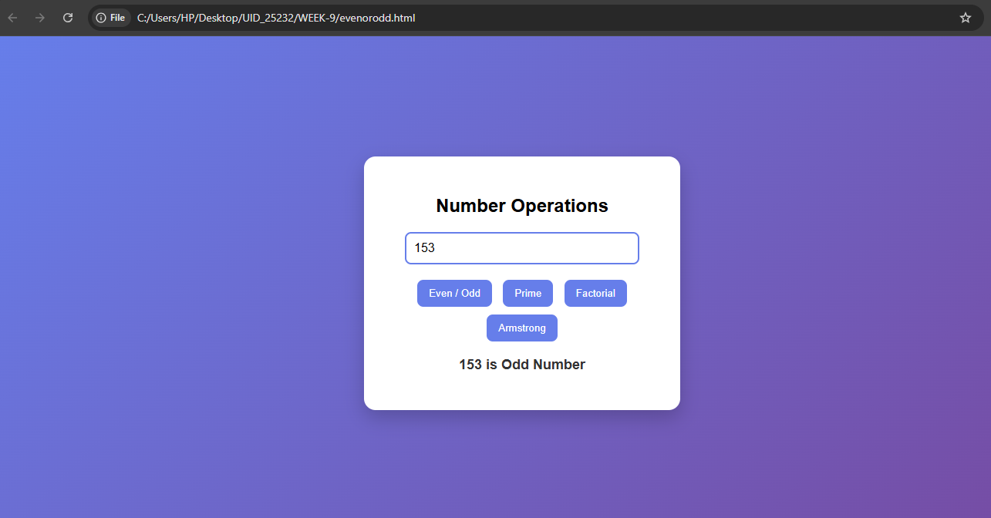

For prime:

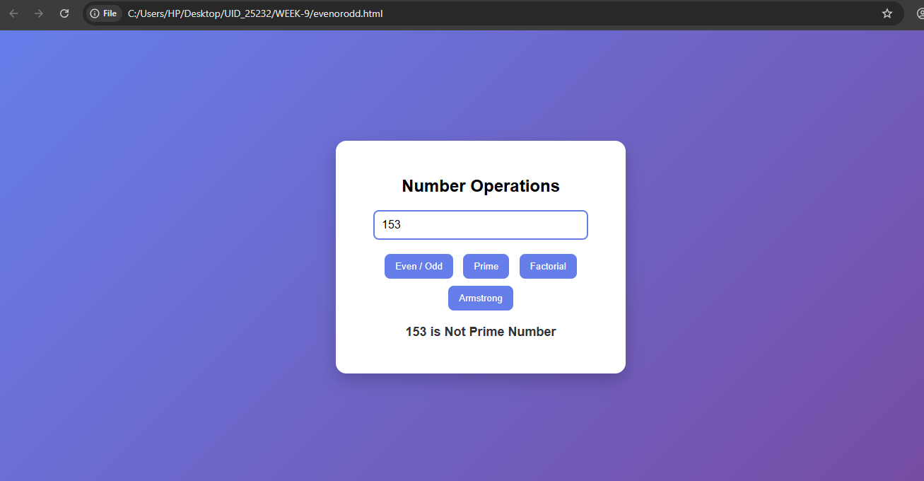

For Factorial if number = 5

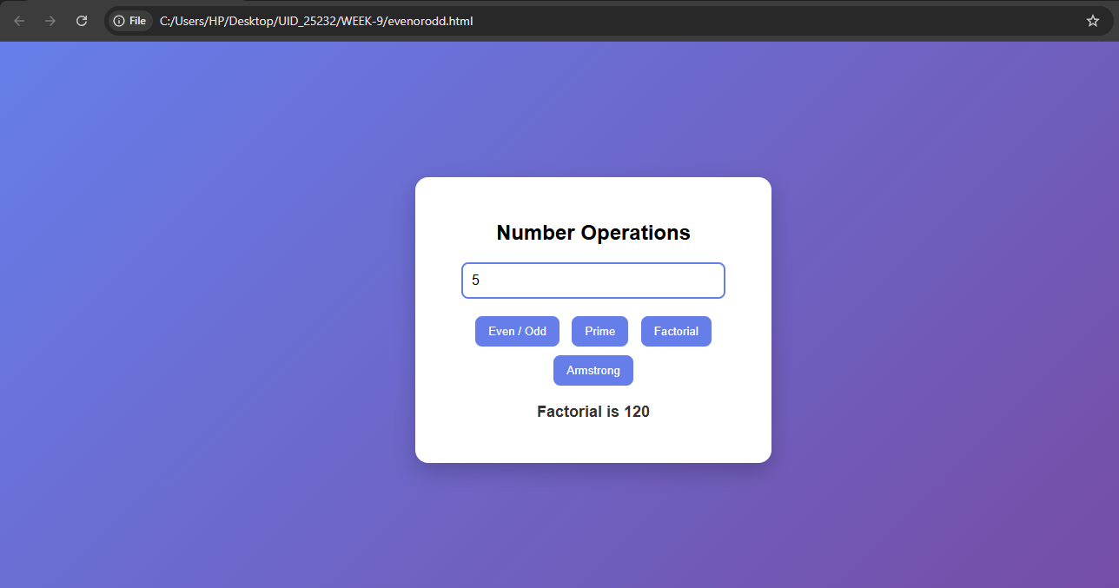

For Armstrong number:

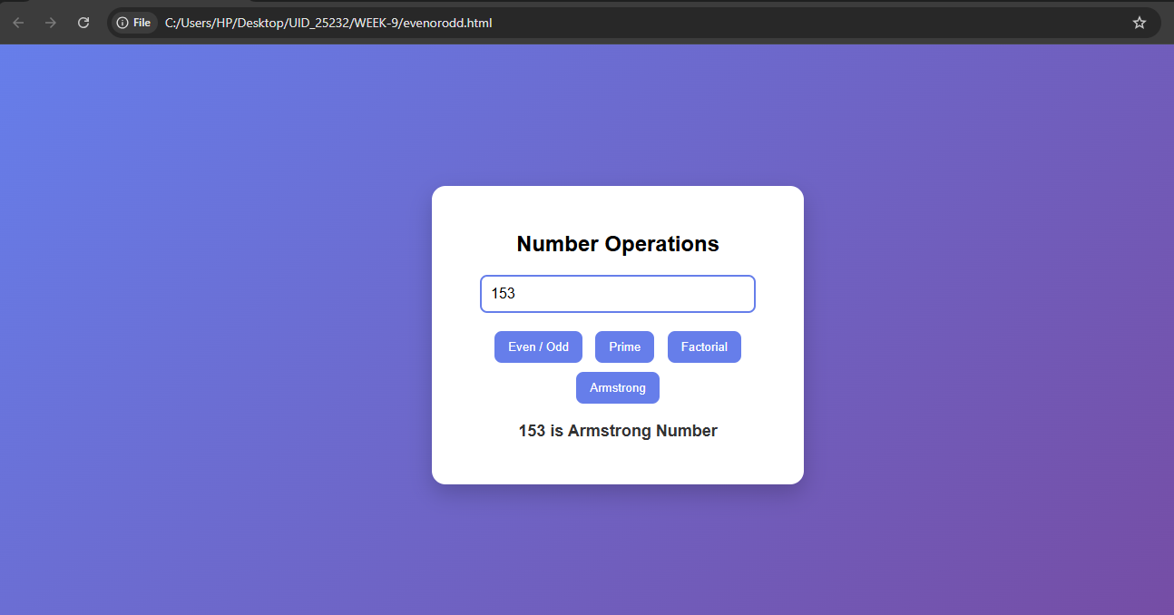

Explanation of tags:-

<button>
- Creates clickable buttons
- onclick="functionName()" → calls JS function.

<p id="result">
- Paragraph used to display output
- id="result" → accessed in JavaScript.
background: linear-gradient(135deg, #667eea, #764ba2);
Creates a gradient background.
display: flex;
justify-content: center;
align-items: center;
height: 100vh;
Centers the container horizontally + vertically.

.container
background: white;
padding: 30px;
border-radius: 15px;
- Creates a card-like box
box-shadow: 0 10px 25px rgba(0,0,0,0.2);
- Adds shadow → gives 3D effect

input
border: 2px solid #667eea;
border-radius: 8px;
- Styled input box with rounded edges

button
background: #667eea;
color: white;
cursor: pointer;
- Blue button with white text
transition: 0.3s;
- Smooth hover animation

button:hover
background: #5a67d8;
- Changes color when mouse hovers

result
font-weight: bold;
- Makes output bold and visible.
function checkEvenOdd()
let a = document.getElementById("num").value;
- Gets value from input box
if (a % 2 == 0)
- Checks if divisible by 2
result.innerHTML = ...
- Displays output in <p id="result">

2. Prime Number Function
for (let i = 1; i <= n; i++)
- Loop from 1 to n
if (n % i == 0) count++;
- Counts factors
if (count == 2)
- Prime → only 2 factors

3. Factorial Function
let k = 1;
- Stores result
k *= i;
- Multiply numbers from 1 to n
Example:
5! = 1×2×3×4×5 = 120

4. Armstrong Function
while (n > 0)
- Extract digits
let r = n % 10;
- Gets last digit
sum += r*r*r;
- Cube of digits added
if (sum == temp)
- Check Armstrong condition

WEEK-10
Aim:- a)Write a JavaScript conditional statement to find the sign of product of three numbers using functions.Display an alert box with the specified sign.
Code:-
<!DOCTYPE html>
<html>
<head>
<title>Sign of Product</title>

<style>
body {
font-family: Arial;
background: linear-gradient(135deg, #1d2671, #c33764);
display: flex;
justify-content: center;
align-items: center;
height: 100vh;
margin: 0;
}

.container {
background: #ffffff;
padding: 30px;
border-radius: 15px;
text-align: center;
box-shadow: 0 10px 25px rgba(0,0,0,0.3);
width: 320px;
}

h2 {
color: #1d2671;
}

input {
padding: 10px;
width: 80%;
margin: 8px;
border-radius: 8px;
border: 2px solid #1d2671;
outline: none;
}

input:focus {
border-color: #c33764;
}

button {
margin-top: 15px;
padding: 10px 20px;
border: none;
border-radius: 8px;
background: #28a745;
color: white;
font-size: 16px;
cursor: pointer;
transition: 0.3s;
}

button:hover {
background: #218838;
}
</style>

<script>
function findSign() {
let a = document.getElementById("num1").value;
let b = document.getElementById("num2").value;
let c = document.getElementById("num3").value;

let product = a * b * c;

if (product > 0) {
alert("The sign is plus (+)");
} else if (product < 0) {
alert("The sign is minus (-)");
} else {
alert("The product is zero (0)");
}
}
</script>

</head>

<body>

<div class="container">
<h2>Sign of Product</h2>

<input type="number" id="num1" placeholder="Enter first number">
<input type="number" id="num2" placeholder="Enter second number">
<input type="number" id="num3" placeholder="Enter third number">

<br>

<button onclick="findSign()">Check Sign</button>
</div>

</body>
</html>
Output:-
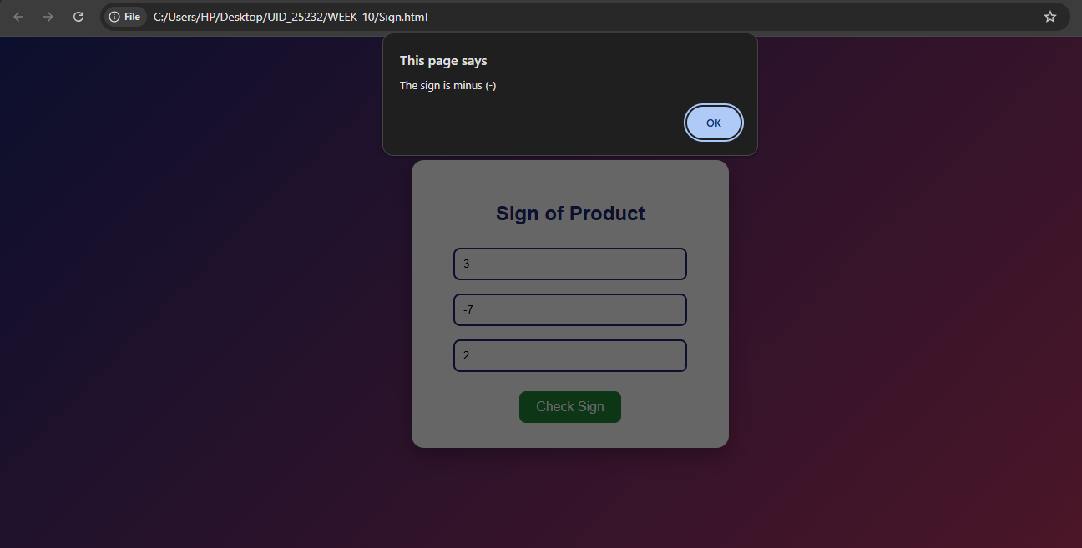
Explanation of tags:-

<button>
- Creates clickable button
- onclick="findSign()" → calls JavaScript function.
background: linear-gradient(135deg, #1d2671, #c33764);
- Creates a gradient background (blue → pink)
display: flex;
justify-content: center;
align-items: center;
height: 100vh;
- Centers content vertically + horizontally

.container
background: #ffffff;
padding: 30px;
border-radius: 15px;
- White card design with spacing and rounded corners
box-shadow: 0 10px 25px rgba(0,0,0,0.3);
- Adds shadow → 3D effect

h2
color: #1d2671;
- Changes heading color to dark blue
input
border: 2px solid #1d2671;
border-radius: 8px;
- Styled input box with border and rounded edges
outline: none;
- Removes default browser outline

input:focus
border-color: #c33764;
- Changes border color when user clicks input

button
background: #28a745;
color: white;
- Green button with white text
cursor: pointer;
transition: 0.3s;
- Pointer cursor + smooth hover effect

button:hover
background: #218838;
- Darker green when mouse hovers.
function findSign()
- Function runs when button is clicked

Getting Input Values
let a = document.getElementById("num1").value;
let b = document.getElementById("num2").value;
let c = document.getElementById("num3").value;
- Fetches values from input fields

Product Calculation
let product = a * b * c;
- Multiplies the three numbers

Conditional Statements
if (product > 0)
- Product is positive
else if (product < 0)
- Product is negative
else
- Product is zero
Output using Alert
alert("message");
- Displays result in a popup box.
b)Aim:-Write a JavaScript conditional statements to sort three numbers using functions.Display an alert box to show result.
Code:-
<!DOCTYPE html>
<html>
<head>
<title>Sort Three Numbers</title>

<style>
body {
font-family: Arial;
background: linear-gradient(135deg, #11998e, #38ef7d);
display: flex;
justify-content: center;
align-items: center;
height: 100vh;
margin: 0;
}

.container {
background: white;
padding: 30px;
border-radius: 15px;
text-align: center;
box-shadow: 0 10px 25px rgba(0,0,0,0.3);
width: 320px;
}

h2 {
color: #11998e;
margin-bottom: 20px;
}

input {
padding: 10px;
width: 80%;
margin: 8px;
border-radius: 8px;
border: 2px solid #11998e;
font-size: 16px;
outline: none;
}

input:focus {
border-color: #38ef7d;
}

button {
margin-top: 15px;
padding: 10px 20px;
border: none;
border-radius: 8px;
background: #11998e;
color: white;
font-size: 16px;
cursor: pointer;
transition: 0.3s;
}

button:hover {
background: #0f7f75;
}
</style>

<script>
function sortNumbers() {
let a = Number(document.getElementById("num1").value);
let b = Number(document.getElementById("num2").value);
let c = Number(document.getElementById("num3").value);

let result;

if (a >= b && a >= c) {
if (b >= c)
result = a + "," + b + "," + c;
else
result = a + "," + c + "," + b;
}
else if (b >= a && b >= c) {
if (a >= c)
result = b + "," + a + "," + c;
else
result = b + "," + c + "," + a;
}
else {
if (a >= b)
result = c + "," + a + "," + b;
else
result = c + "," + b + "," + a;
}

alert("Sorted order: " + result);
}
</script>

</head>

<body>

<div class="container">
<h2>Sort Three Numbers</h2>

<input type="number" id="num1" placeholder="Enter first number">
<input type="number" id="num2" placeholder="Enter second number">
<input type="number" id="num3" placeholder="Enter third number">

<br>

<button onclick="sortNumbers()">Sort</button>
</div>

</body>
</html>
Output:-
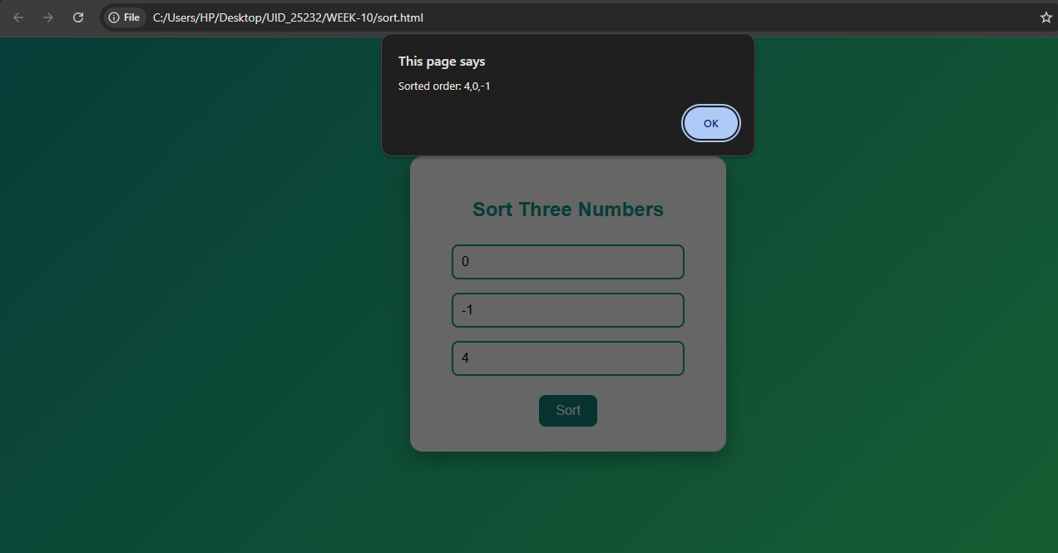

Explanation of tags:-
background: linear-gradient(135deg, #11998e, #38ef7d);
- Creates green gradient background
display: flex;
justify-content: center;
align-items: center;
height: 100vh;
- Centers content vertically & horizontally
.container
background: white;
padding: 30px;
border-radius: 15px;
- Creates a white card with spacing and rounded corners
box-shadow: 0 10px 25px rgba(0,0,0,0.3);
- Adds shadow → 3D effect

h2
color: #11998e;
- Changes heading color

input
border: 2px solid #11998e;
border-radius: 8px;
- Styled input fields
outline: none;
- Removes default border highlight

input:focus
border-color: #38ef7d;
- Changes border color when clicked

button
background: #11998e;
color: white;
- Green button with white text
cursor: pointer;
transition: 0.3s;
- Pointer cursor + smooth hover

button:hover
background: #0f7f75;
- Darker green on hover
function sortNumbers()
- Runs when button is clicked

Getting Input Values
let a = Number(document.getElementById("num1").value);
let b = Number(document.getElementById("num2").value);
let c = Number(document.getElementById("num3").value);
- Reads input values
- Number() converts string → number

Sorting Logic (Conditional Statements)

Step 1: Find largest number
if (a >= b && a >= c)
- Checks if a is largest

Step 2: Compare remaining numbers
if (b >= c)
- Decides order of b and c

Step 3: Repeat for other cases
- When b is largest
- When c is largest

Result Formation
result = a + "," + b + "," + c;
- Creates output string in descending order.
c)Aim:-Write a JavaScript conditional statements to find the largest of five numbers using function and on click event.Display an alert box to show the result.

Code:-

<!DOCTYPE html>
<html>
<head>
<title>Largest of Five Numbers</title>

<style>
body {
font-family: Arial;
background: linear-gradient(135deg, #ff7e5f, #feb47b);
display: flex;
justify-content: center;
align-items: center;
height: 100vh;
margin: 0;
}

.container {
background: white;
padding: 30px;
border-radius: 15px;
text-align: center;
box-shadow: 0 10px 25px rgba(0,0,0,0.3);
width: 340px;
}

h2 {
color: #ff7e5f;
}

input {
padding: 10px;
width: 80%;
margin: 6px;
border-radius: 8px;
border: 2px solid #ff7e5f;
outline: none;
}

input:focus {
border-color: #feb47b;
}

button {
margin-top: 15px;
padding: 10px 20px;
border: none;
border-radius: 8px;
background: #ff7e5f;
color: white;
font-size: 16px;
cursor: pointer;
}

button:hover {
background: #e96a50;
}
</style>

<script>
function findLargest() {
let a = Number(document.getElementById("n1").value);
let b = Number(document.getElementById("n2").value);
let c = Number(document.getElementById("n3").value);
let d = Number(document.getElementById("n4").value);
let e = Number(document.getElementById("n5").value);

let largest;

if (a >= b && a >= c && a >= d && a >= e)
largest = a;
else if (b >= a && b >= c && b >= d && b >= e)
largest = b;
else if (c >= a && c >= b && c >= d && c >= e)
largest = c;
else if (d >= a && d >= b && d >= c && d >= e)
largest = d;
else
largest = e;

alert("Largest number is: " + largest);
}
</script>

</head>

<body>

<div class="container">
<h2>Largest of Five Numbers</h2>

<input type="number" id="n1" placeholder="Enter first number">
<input type="number" id="n2" placeholder="Enter second number">
<input type="number" id="n3" placeholder="Enter third number">
<input type="number" id="n4" placeholder="Enter fourth number">
<input type="number" id="n5" placeholder="Enter fifth number">

<br>

<button onclick="findLargest()">Find Largest</button>
</div>

</body>
</html>

Output:-
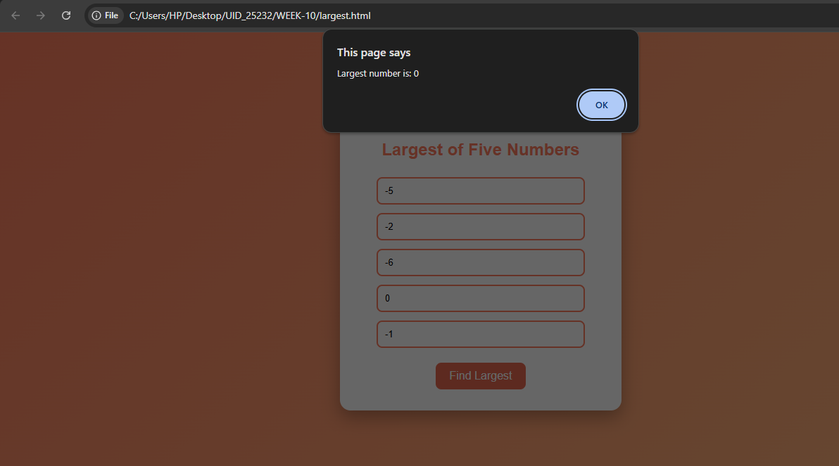
Explanation of tags:-
background: linear-gradient(135deg, #ff7e5f, #feb47b);
- Creates orange gradient background
display: flex;
justify-content: center;
align-items: center;
height: 100vh;
- Centers content horizontally & vertically

.container
background: white;
padding: 30px;
border-radius: 15px;
- Creates a white card with spacing and rounded corners
box-shadow: 0 10px 25px rgba(0,0,0,0.3);
- Adds shadow → 3D effect

h2
color: #ff7e5f;
- Sets heading color

input
border: 2px solid #ff7e5f;
border-radius: 8px;
- Styled input fields
outline: none;
- Removes default browser outline

input:focus
border-color: #feb47b;
- Changes border color when clicked

button
background: #ff7e5f;
color: white;
- Orange button with white text
cursor: pointer;
- Shows pointer on hover

button:hover
background: #e96a50;
- Darker color when mouse hovers.
function findLargest()
- Function runs when button is clicked

Getting Input Values
let a = Number(document.getElementById("n1").value);
- Reads value from input box
- Number() converts string → number
(Same for b, c, d, e)

Logic to Find Largest Number

Step 1: Compare all values
if (a >= b && a >= c && a >= d && a >= e)
- Checks if a is largest

Step 2: Check other numbers
else if (b >= a && b >= c && b >= d && b >= e)
- Checks if b is largest
(Same for c and d)
Step 3: Default case
else
largest = e;
- If none of above → e is largest

Output
alert("Largest number is: " + largest);
- Displays result in alert box (popup).
d)Aim:-Write a JavaScript for loop that will iterate from 0 to 15.For each iteration, it will check if the current number is odd or even, and display a message to the screen.
Code:-
<!DOCTYPE html>
<html>
<head>
<title>Even or Odd (0 to 15)</title>

<style>
body {
font-family: Arial;
background: linear-gradient(135deg, #36d1dc, #5b86e5);
display: flex;
justify-content: center;
align-items: center;
height: 100vh;
margin: 0;
}

.container {
background: white;
padding: 30px;
border-radius: 15px;
text-align: center;
box-shadow: 0 10px 25px rgba(0,0,0,0.3);
width: 350px;
}

h2 {
color: #5b86e5;
}

button {
padding: 10px 20px;
border: none;
border-radius: 8px;
background: #5b86e5;
color: white;
cursor: pointer;
margin-top: 10px;
}

button:hover {
background: #3f6fd1;
}

#output {
margin-top: 15px;
text-align: left;
font-size: 16px;
}
</style>

<script>
function checkNumbers() {
let text = "";

for (let i = 0; i <= 15; i++) {
if (i % 2 == 0) {
text += i + " is even<br>";
} else {
text += i + " is odd<br>";
}
}

document.getElementById("output").innerHTML = text;
}
</script>

</head>

<body>

<div class="container">
<h2>Even or Odd (0–15)</h2>

<button onclick="checkNumbers()">Show Result</button>

<div id="output"></div>
</div>

</body>
</html>

Output:-
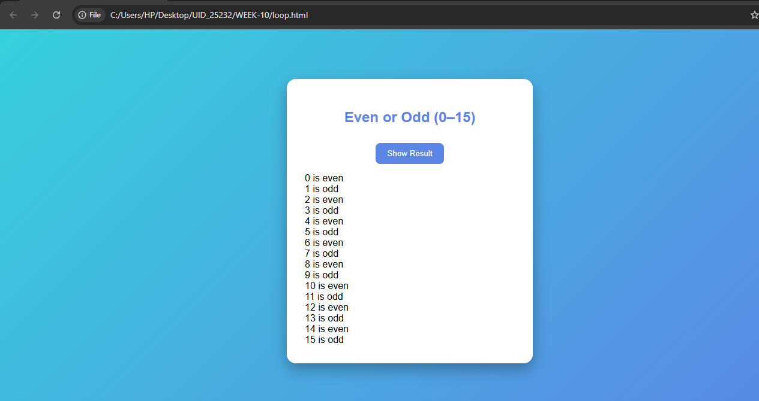
Explanation of the tags:-
background: linear-gradient(135deg, #36d1dc, #5b86e5);
- Creates a blue gradient background
display: flex;
justify-content: center;
align-items: center;
height: 100vh;
- Centers content vertically + horizontally

.container
background: white;
padding: 30px;
border-radius: 15px;
- Creates a white card with spacing and rounded corners
box-shadow: 0 10px 25px rgba(0,0,0,0.3);
- Adds shadow → gives 3D effect

h2
color: #5b86e5;
- Changes heading color

button
background: #5b86e5;
color: white;
- Blue button with white text
cursor: pointer;
- Changes cursor to pointer

button:hover
background: #3f6fd1;
- Darker color when mouse hovers

#output
text-align: left;
font-size: 16px;
- Aligns output text to left
- Sets readable font size.

WEEK-11
1.Aim:- A website requires users to enter a username. The system should display a message while typing if the username is less than 5 characters.
Code:-
<!DOCTYPE html>
<html>
<head>
<title>Username Validation</title>
<style>
body {
font-family: Arial;
margin: 30px;
}
#message {
color: red;
font-size: 14px;
}
</style>
</head>
<body>

<h2>Enter Username</h2>

<input type="text" id="username" placeholder="Enter username">
<p id="message"></p>

<script>
let usernameInput = document.getElementById("username");
let message = document.getElementById("message");

usernameInput.addEventListener("input", function() {
let value = usernameInput.value;

if (value.length < 5) {
message.textContent = "Username must be at least 5 characters";
} else {
message.textContent = "Username is valid";
message.style.color = "green";
}

if (value.length === 0) {
message.textContent = "";
}
});
</script>

</body>
</html>

Output:-
If we enter less than four characters then the output is
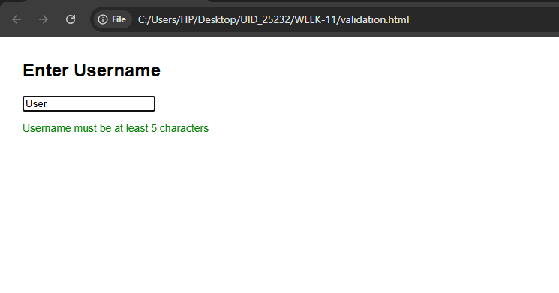
If we enter five or more than five characters then the output is
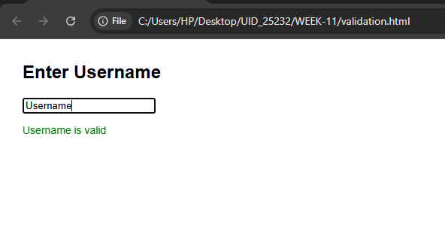
Explanation of tags:-
body {
font-family: Arial;
margin: 30px;
}
- font-family: Arial; → sets text font
- margin: 30px; → adds space around the page
#message {
color: red;
font-size: 14px;
}
- #message → targets the <p> with id="message"
- color: red; → default message color
- font-size: 14px; → text size
let usernameInput = document.getElementById("username");
let message = document.getElementById("message");
- document.getElementById() → selects HTML elements using their ID
- usernameInput → refers to input box
- message → refers to paragraph

usernameInput.addEventListener("input", function() {
- "input" event → triggers every time user types
- Runs the function automatically on typing
let value = usernameInput.value;
- Gets current text entered by user
Case 1: Less than 5 characters
if (value.length < 5) {
message.textContent = "Username must be at least 5 characters";
}
- Checks length of input
- Shows error message

Case 2: Valid username
else {
message.textContent = "Username is valid";
message.style.color = "green";
}
- Displays success message
- Changes text color to green

Case 3: Empty input
if (value.length === 0) {
message.textContent = "";
}
- Clears message if nothing is typed.

2.Aim:- A registration form should validate email format before submission. If invalid, the form should not be submitted.
Code:-
<!DOCTYPE html>
<html>
<head>
<title>Email Validation</title>
<style>
body {
font-family: Arial;
margin: 30px;
}
#error {
color: red;
}
</style>
</head>
<body>

<h2>Registration Form</h2>

<form id="regForm">
<label>Email:</label><br>
<input type="text" id="email"><br><br>
<p id="error"></p>

<button type="submit">Submit</button>
</form>

<script>
document.getElementById("regForm").addEventListener("submit", function(event) {

let email = document.getElementById("email").value;
let error = document.getElementById("error");

let pattern = /^[^ ]+@[^ ]+\.[a-z]{2,3}$/;

if (!pattern.test(email)) {
error.textContent = "Invalid email format";
event.preventDefault();
} else {
error.textContent = "";
}
});
</script>

</body>
</html>

Output:-
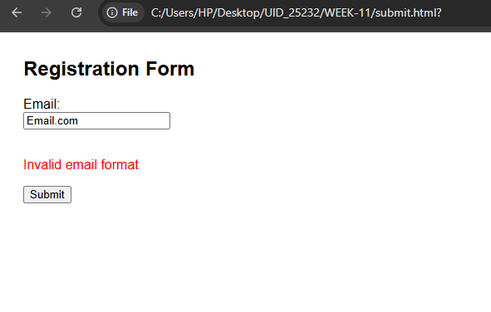
Explanation of tags:-
body {
font-family: Arial;
margin: 30px;
}
- font-family: Arial; → sets text font
- margin: 30px; → adds space around page
#error {
color: red;
}
- Targets <p id="error">
- Displays error text in red
document.getElementById("regForm").addEventListener("submit", function(event)
- Listens for form submission
- Runs function when user clicks Submit

2. Getting Values
let email = document.getElementById("email").value;
let error = document.getElementById("error");
- email → stores entered email value
- error → refers to paragraph element

3. Email Pattern
let pattern = /^[^ ]+@[^ ]+\.[a-z]{2,3}$/;
This is a regular expression (pattern) used to validate email.

Breakdown:
Example valid emails:
- abc@gmail.com
- user123@yahoo.in
Invalid:
- abc@.com
- abc@gmail
- abc gmail.com
if (!pattern.test(email))
- .test() checks if email matches pattern
- ! means NOT valid

If Invalid
error.textContent = "Invalid email format";
event.preventDefault();
- Shows error message
- event.preventDefault() → stops form submission

If Valid
error.textContent = "";
- Clears error message
3.Aim:- A system should check password strength while typing and display whether it is weak or strong.
Code:-
<!DOCTYPE html>
<html>
<head>
<title>Password Strength Checker</title>
<style>
body {
font-family: Arial;
margin: 30px;
}
#strength {
font-weight: bold;
}
</style>
</head>
<body>

<h2>Enter Password</h2>

<input type="password" id="password" placeholder="Enter password">
<p id="strength"></p>

<script>
let passwordInput = document.getElementById("password");
let strengthText = document.getElementById("strength");

passwordInput.addEventListener("input", function() {
let password = passwordInput.value;

// Conditions
let hasUpper = /[A-Z]/.test(password);
let hasLower = /[a-z]/.test(password);
let hasNumber = /[0-9]/.test(password);
let hasSpecial = /[!@#$%^&*]/.test(password);

if (password.length < 6) {
strengthText.textContent = "Weak Password";
strengthText.style.color = "red";
}
else if (hasUpper && hasLower && hasNumber && hasSpecial) {
strengthText.textContent = "Strong Password";
strengthText.style.color = "green";
}
else {
strengthText.textContent = "Medium Password";
strengthText.style.color = "orange";
}

if (password.length === 0) {
strengthText.textContent = "";
}
});
</script>

</body>
</html>
Output:-
If we enter only lowercase alphabets then it displays weak password.
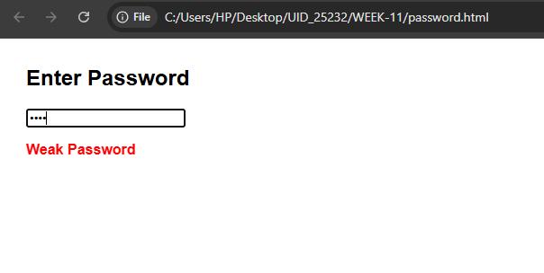

If we enter both lowercase alphabets and uppercase then it displays medium password.
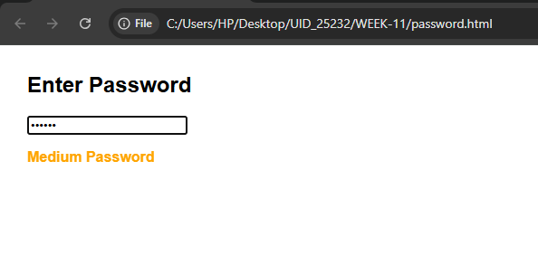
If we enter all lowercase, uppercase, special characters and numbers then it displays strong password.
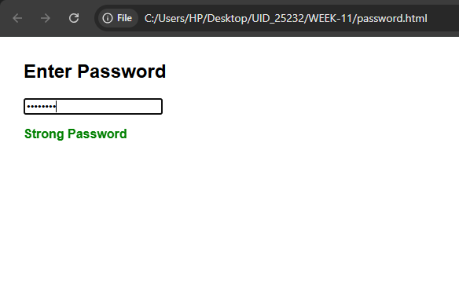

Explanation of tags:-
body {
font-family: Arial;
margin: 30px;
}
- font-family: Arial; → sets text font
- margin: 30px; → gives spacing around page
#strength {
font-weight: bold;
}
- #strength → targets <p id="strength">
- font-weight: bold; → makes text bold.
let passwordInput = document.getElementById("password");
let strengthText = document.getElementById("strength");
- Accesses HTML elements using their IDs
- passwordInput → input box
- strengthText → paragraph for result

2. Event Listener
passwordInput.addEventListener("input", function()
- "input" event → runs every time user types
- Enables real-time checking

3. Getting Password Value
let password = passwordInput.value;
- Stores current password entered by user

4. Checking Conditions (Regex)
These lines check if password contains required characters:
let hasUpper = /[A-Z]/.test(password);
- Checks for uppercase letter (A–Z)
let hasLower = /[a-z]/.test(password);
- Checks for lowercase letter (a–z)
let hasNumber = /[0-9]/.test(password);
- Checks for numbers (0–9)
let hasSpecial = /[!@#$%^&*]/.test(password);
- Checks for special characters
.test() returns:
- true → condition satisfied
- false → condition not satisfied

5. Password Strength Logic

Weak Password
if (password.length < 6)
- Less than 6 characters
- Output: "Weak Password"
- Color: red

Strong Password
else if (hasUpper && hasLower && hasNumber && hasSpecial)
- Must contain:
  - uppercase
  - lowercase
  - number
  - special character
- Output: "Strong Password"
- Color: green

Medium Password
else
- Meets length but missing some conditions
- Output: "Medium Password"
- Color: orange

6. Empty Input Handling
if (password.length === 0)
- If user deletes everything
- Clears message.
4.Aim:- A form should validate a mobile number when the user leaves the input field. The number must be exactly 10 digits.
Code:-
<!DOCTYPE html>
<html>
<head>
<title>Mobile Validation</title>
</head>
<body>

<h3>Enter Mobile Number:</h3>
<input type="text" id="mobile" placeholder="Enter 10-digit number">
<p id="message"></p>

<script>
let input = document.getElementById("mobile");

input.addEventListener("blur", function() {
let mobile = input.value;
let message = document.getElementById("message");
let pattern = /^[0-9]{10}$/;

if (pattern.test(mobile)) {
message.innerHTML = "Valid mobile number";
message.style.color = "green";
} else {
message.innerHTML = "Invalid mobile number";
message.style.color = "red";
}
});
</script>

</body>
</html>
Output:-
If we enter 9 or less than that digits then it displays enter valid number.
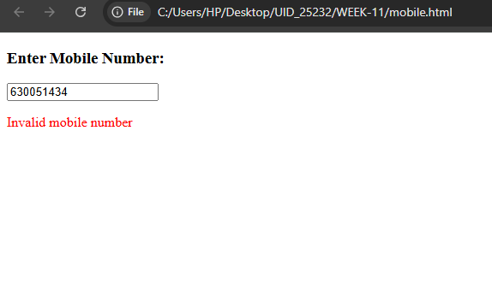
If we enter 10 digits then it displays valid mobile number.
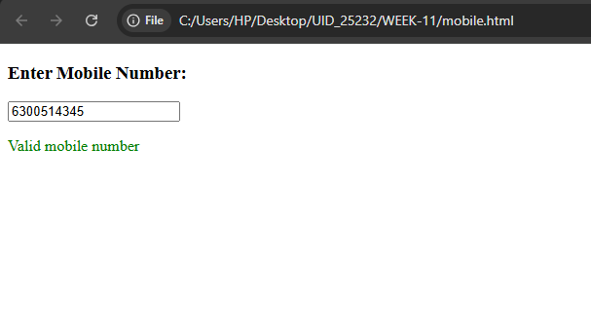
Explanation of tags:-
let input = document.getElementById("mobile");
- Gets the <input> element using its ID
- Stored in variable input

Event Listener (blur)
input.addEventListener("blur", function()
- "blur" event → triggers when the user leaves the input field
- Example:
  - User types number
  - Clicks outside → validation runs

Getting Input Value
let mobile = input.value;
- Reads the value entered by the user

Selecting Message Element
let message = document.getElementById("message");
- Gets the <p> element to display result

Regular Expression (Pattern)
let pattern = /^[0-9]{10}$/;

Meaning:
- ^ → start of string
- [0-9] → only digits allowed
- {10} → exactly 10 digits
- $ → end of string
Accepts:
- 9876543210
- 1234567890
Rejects:
- 98765 (too short)
- 12345678901 (too long)
- 98a6543210 (contains letter)

Validation Check
if (pattern.test(mobile))
- .test() checks if input matches pattern
- Returns:
  - true → valid
  - false → invalid

If Valid
message.innerHTML = "Valid mobile number";
message.style.color = "green";
- Displays success message
- Changes text color to green

If Invalid
message.innerHTML = "Invalid mobile number";
message.style.color = "red";
- Displays error message
- Changes text color to red.

5.Aim:- Design an HTML page, such that the registration form must validate:
Name (not empty)
Email (valid format)
Password (minimum 6 characters)
Code:-
<!DOCTYPE html>
<html>
<head>
<title>Registration Form</title>
<style>
body {
font-family: Arial;
}
.error {
color: red;
}
.success {
color: green;
}
</style>
</head>
<body>

<h2>Registration Form</h2>

<form id="myForm">
Name: <br>
<input type="text" id="name"><br><br>

Email: <br>
<input type="text" id="email"><br><br>

Password: <br>
<input type="password" id="password"><br><br>

<button type="submit">Register</button>
</form>

<p id="message"></p>

<script>
document.getElementById("myForm").addEventListener("submit", function(event) {

let name = document.getElementById("name").value.trim();
let email = document.getElementById("email").value.trim();
let password = document.getElementById("password").value.trim();
let message = document.getElementById("message");

let emailPattern = /^[^\s@]+@[^\s@]+\.[^\s@]+$/;

if (name === "") {
event.preventDefault();
message.innerHTML = "Name cannot be empty";
message.className = "error";
}
else if (!emailPattern.test(email)) {
event.preventDefault();
message.innerHTML = "Enter a valid email";
message.className = "error";
}
else if (password.length < 6) {
event.preventDefault();
message.innerHTML = "Password must be at least 6 characters";
message.className = "error";
}
else {
message.innerHTML = "Form submitted successfully!";
message.className = "success";
}
});
</script>

</body>
</html>
Output:-
If we do not enter any name then it displays name cannot be empty.
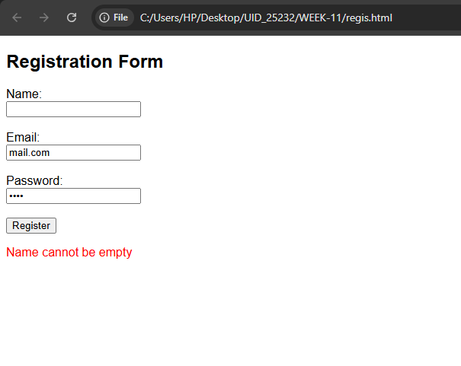
If we do not enter valid email then it displays enter a valid email.
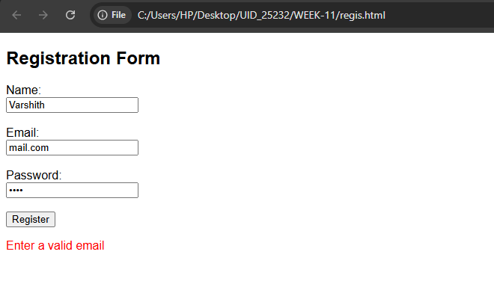
If we enter password less than 6 characters then it displays password must be at least 6 characters.
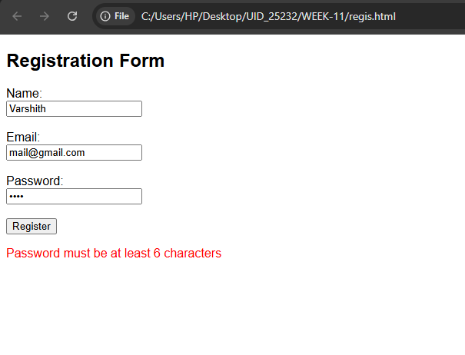
Explanation of tags:-
<form id="myForm">
- Creates a form for user input
- id="myForm" → used in JavaScript to access the form

Input Fields

Name
<input type="text" id="name">
- Takes user name
- type="text" → normal text input
- id="name" → accessed in JavaScript

Email
<input type="text" id="email">
- Takes email input
- id="email" → used for validation

Password
<input type="password" id="password">
- Hides typed characters
- id="password" → used in JS

Submit Button
<button type="submit">Register</button>
- Submits the form
- Triggers validation

Message Display
<p id="message"></p>
- Displays validation messages (error/success).
body {
font-family: Arial;
}
- Sets font style for entire page
.error {
color: red;
}
- Applies red color to error messages
.success {
color: green;
}
- Applies green color to success message.
document.getElementById("myForm").addEventListener("submit", function(event)
- Runs when form is submitted
- event is used to control submission

Getting Input Values
let name = document.getElementById("name").value.trim();
let email = document.getElementById("email").value.trim();
let password = document.getElementById("password").value.trim();
- .value → gets user input
- .trim() → removes extra spaces

Message Element
let message = document.getElementById("message");
- Used to display output messages

Email Pattern (Regex)
let emailPattern = /^[^\s@]+@[^\s@]+\.[^\s@]+$/;
Validates email format:
- [^\s@]+ → characters except space and @
- @ → must contain @
- . → dot
- Ensures proper structure

Validation Conditions

Case 1: Name Empty
if (name === "")
- Checks if name is empty
event.preventDefault();
message.innerHTML = "Name cannot be empty";
message.className = "error";
- Stops form submission
- Shows error message
- Applies red color

Case 2: Invalid Email
else if (!emailPattern.test(email))
- Checks email format
- .test() → returns true/false
event.preventDefault();
message.innerHTML = "Enter a valid email";
message.className = "error";

Case 3: Weak Password
else if (password.length < 6)
- Password must be at least 6 characters
event.preventDefault();
message.innerHTML = "Password must be at least 6 characters";
message.className = "error";

Case 4: All Valid
else
message.innerHTML = "Form submitted successfully!";
message.className = "success";
- Shows success message
- Applies green color
- Form submits normally.

WEEK-12
Aim:-Steps to install Electron website.
Procedure:
Step 1: Go to the web browser and download node.js.
Step 2: After installing the Node.js, complete the setup process.
Step 3: After installing node.js, Open the command prompt and navigate to the folder where your project is located.
Step 4: And give the prompt “node –v” and also "npm –v".
Step 5: If you get the versions then it is successfully installed.

Step 6: Now open PowerShell as Administrator and give the prompt "Set-ExecutionPolicy RemoteSigned".
• This command allows local PowerShell scripts to run securely.
• And press Y.

Create Project Folder :-
Step 7: Create a new folder for the Electron project using mkdir.
Step 8: Move into the project folder using cd.
• This helps keep all project files organized.
Step 9:
Initialize Node Project:-

The above command creates the package.json file.
• This file stores:
1.Project name
2.Version
3. Main entry file
4. Scripts
5. Dependencies
• Without package.json file, npm cannot manage project properly.

Step 10:
Install Electron:-

Downloads Electron package
• Saves it in node modules
• Adds it to devDependencies
• --save-dev→Because Electron is needed during development.
Step 11:
Configure package.json:

Main→Tells Electron which file starts the application.
Start→Defines command used when we run:

Electron → This command runs Electron in the current project folder.
Create Main Application Files:-

Step 12: main.js→Controls app lifecycle and creates windows
Step 13: index.html→User interface
Step 14: style.css→Design and layout
Step 15: renderer.js→Handles user interaction
Write main.js
• Imports Electron modules
• Creates application window
• Loads UI

Run Application:-

